

|  |  |
| --- | --- |
|  | Laboratory Exercise 2: Digital Image Correlation (DIC) Testing |
|  |  |
|  | Nguyen Xuan Binh (887799)  Amini Ehsan (Research assistant) |
|  | MEC-E6007 Mechanical Testing of Materials  26/03/2024 |
|  |  |

# Introduction

Digital Image Correlation (DIC) is an optical technique to measure deformation, displacement, and strain on materials subjected to mechanical loads. This non-contact method uses a high-resolution camera to capture sequential images of a specimen's surface as it undergoes stress. These images typically feature a speckle pattern—a randomly distributed, high-contrast pattern painted or applied on the surface of the material [1]. The DIC system then analyzes changes in this pattern using complex algorithms to compute full-field strain and displacement maps [1]

For this report, we documented the DIC testing conducted on DP800 material, using shear geometry in the preparation and execution stages. The material DP800, known for its high strength and ductility, is a dual-phase steel commonly used in automotive and structural applications where high performance under stress is required.

Our testing was conducted on April 25, 2024, in a controlled lab environment where we aimed to investigate the material behavior under tensile stresses across multiple specimen geometries—Shear (SH), Central Hole (CH), Notched Dob Bone (NDB), and Standard Dob Bone (SDB). Each geometry presents unique challenges and insights into the material properties, making DIC an ideal choice for its ability to provide detailed, localized measurements of deformation.

Unfortunately, due to scheduling conflicts, the post-processing stages were conducted on specimens with the central hole geometry instead of the initially intended shear geometry. Moreover, for reasons pertaining to data privacy, this report will primarily discuss extracted data from the notched dog bone geometry. Nevertheless, the methodologies and general procedures described herein are consistent and applicable across all tested geometries, ensuring that the findings are relevant and can be applied to similar tests on DP800 material.

There is a question that some beginners to DIC may ask is why we must apply a speckle pattern physically on the specimen (such as paint or stickers), instead of computer-generated pattern. The answer is that computer generated patterns simply do not know how it should change over the surface of the specimen to measure its local deformations. Physical speckles simply move along the surface during any deformation tests, telling us information about local strain and how the material deforms over time using image correlation.

There are three stages of DIC testing:

* First, we apply paints on the testing specimen as preprocessing
* Second, we apply the deformation test on the specimen and take pictures during the process
* Third, we postprocess the recorded images into DIC results and visualizations

# DIC testing: Preprocessing stage of applying paint speckles.

## 2.1 Material preparation

Firstly, the specimen preparation was critical to ensure accurate DIC results. The surface of the DP800 material was meticulously cleaned using acetone to remove any contaminants. It was crucial that the middle part of the specimen, where DIC paint would be applied, was not touched post-cleaning to avoid any smudges or residues.

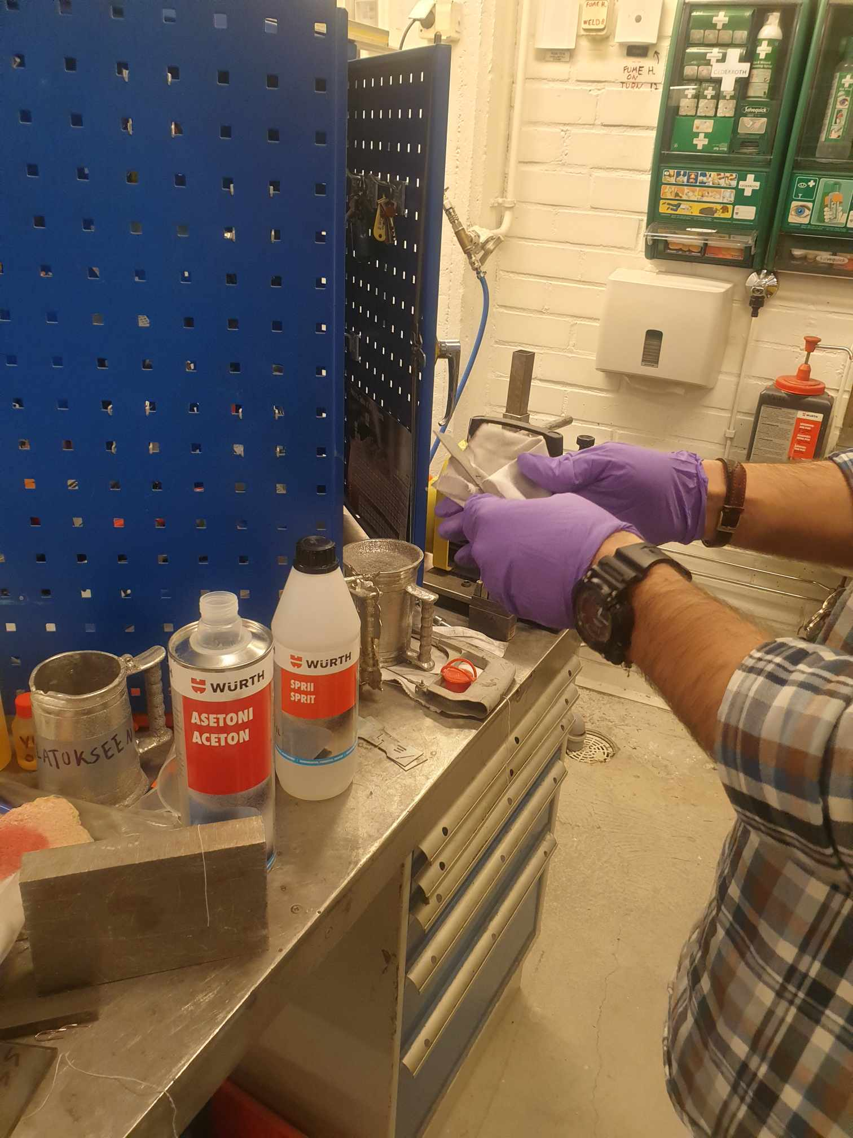 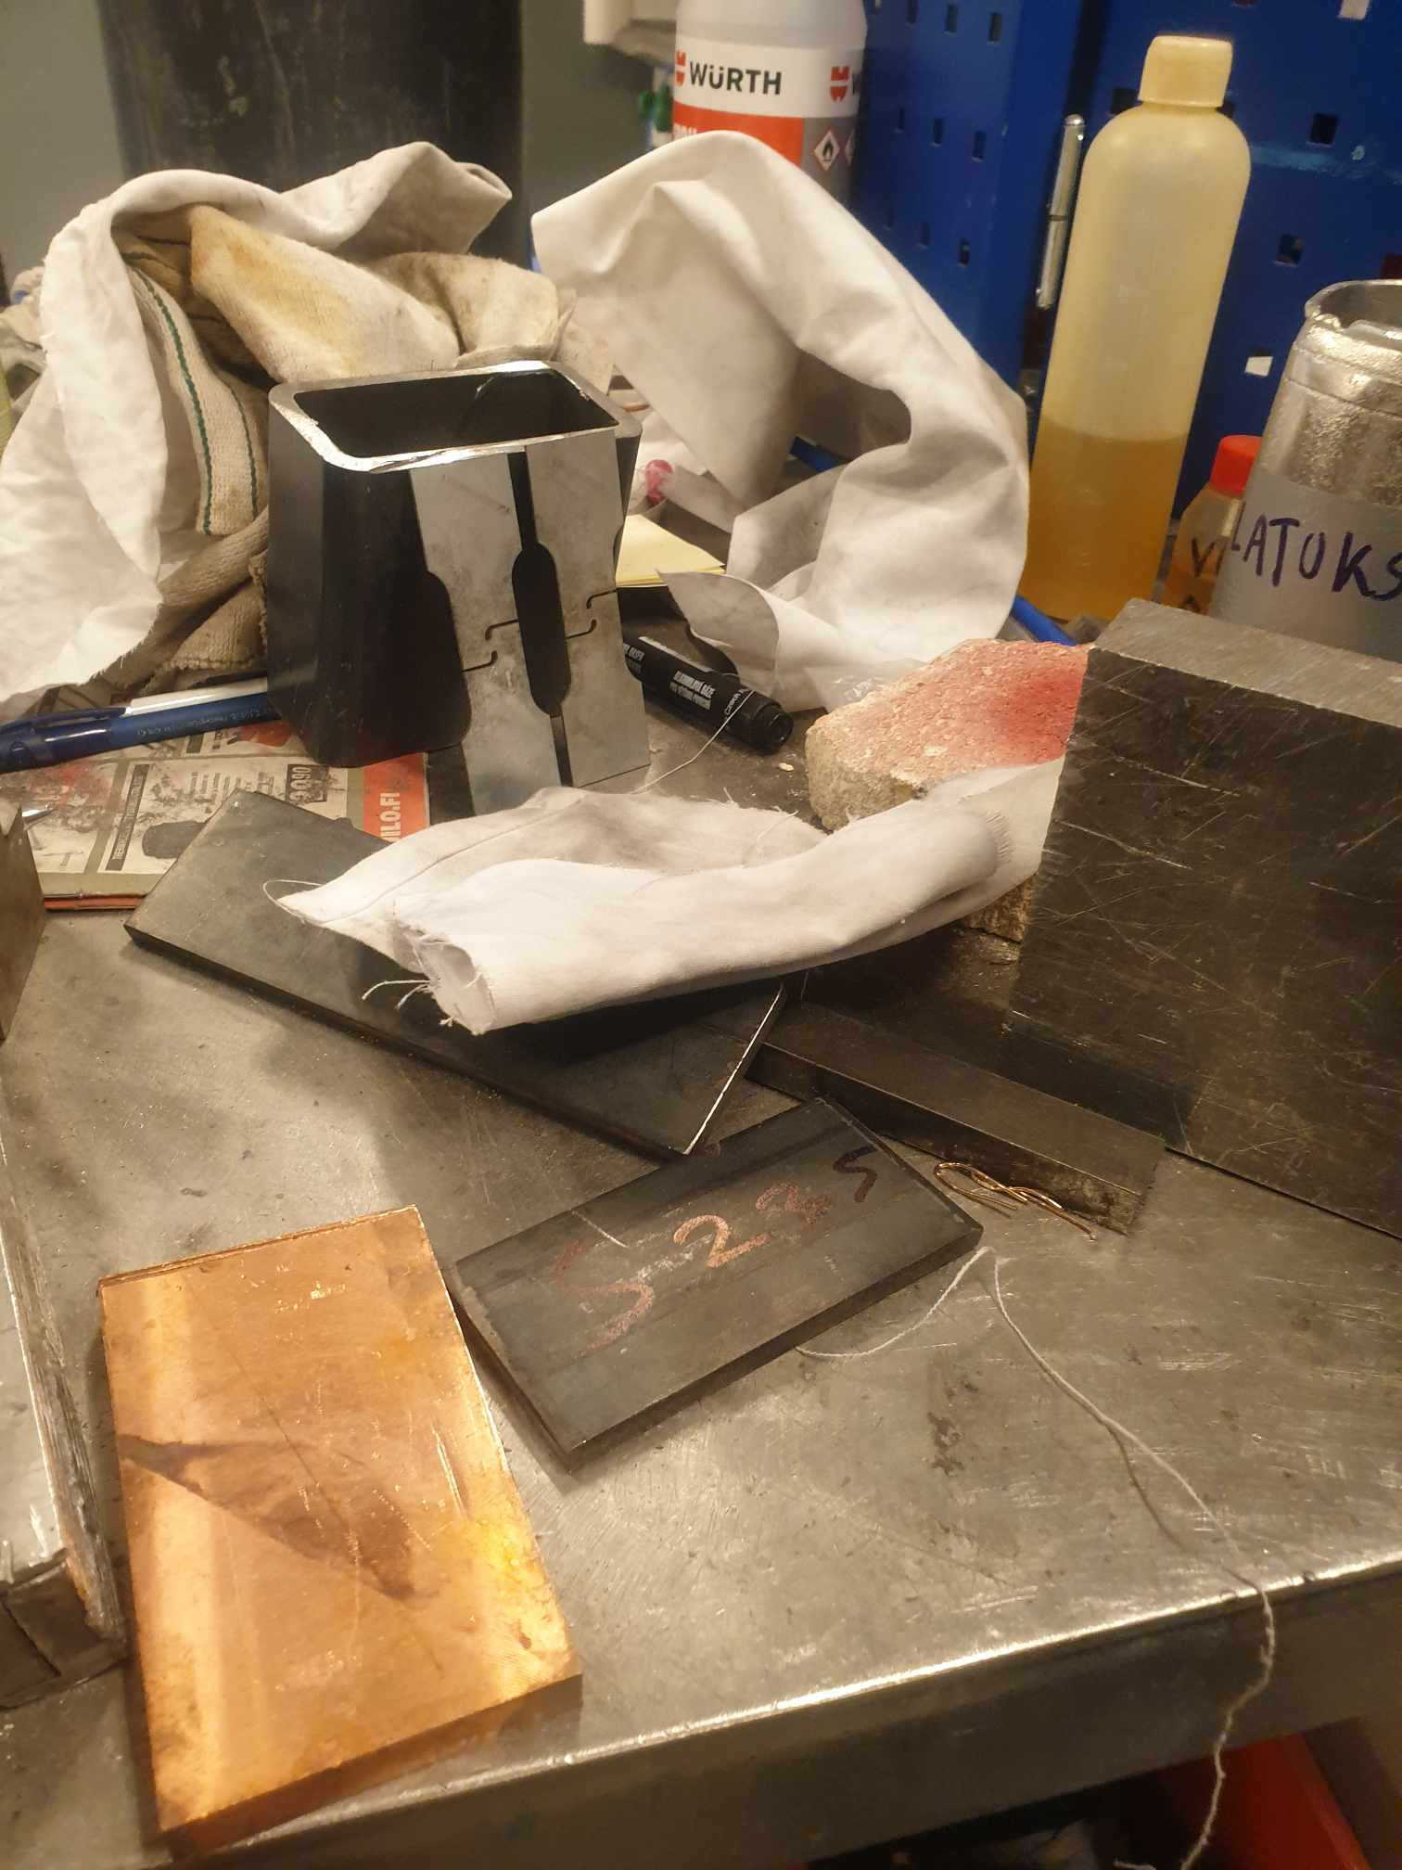

## 2.2 Painting process

General procedures

For DIC analysis, the specimen must have a contrasting speckle pattern. Initially, a white base coat was applied to the cleaned surface. After drying the base coat, a black speckle pattern was added. This speckling process was refined through trial and error to achieve optimal brightness for the DIC equipment, ensuring clear differentiation between speckles. If the speckle quality was found to be inadequate, acetol was used to remove the paint, allowing for a redo of the painting process.

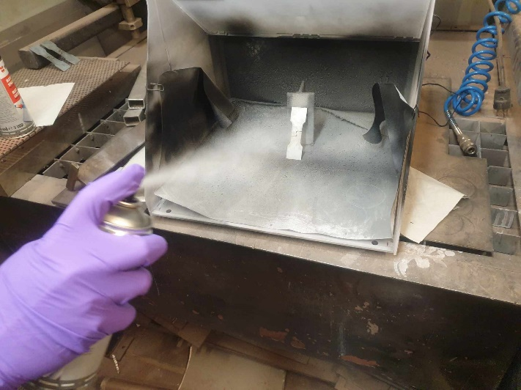

First, we apply the white paint on the specimen. We apply the white paint on the surface until it becomes very shiny and bright.

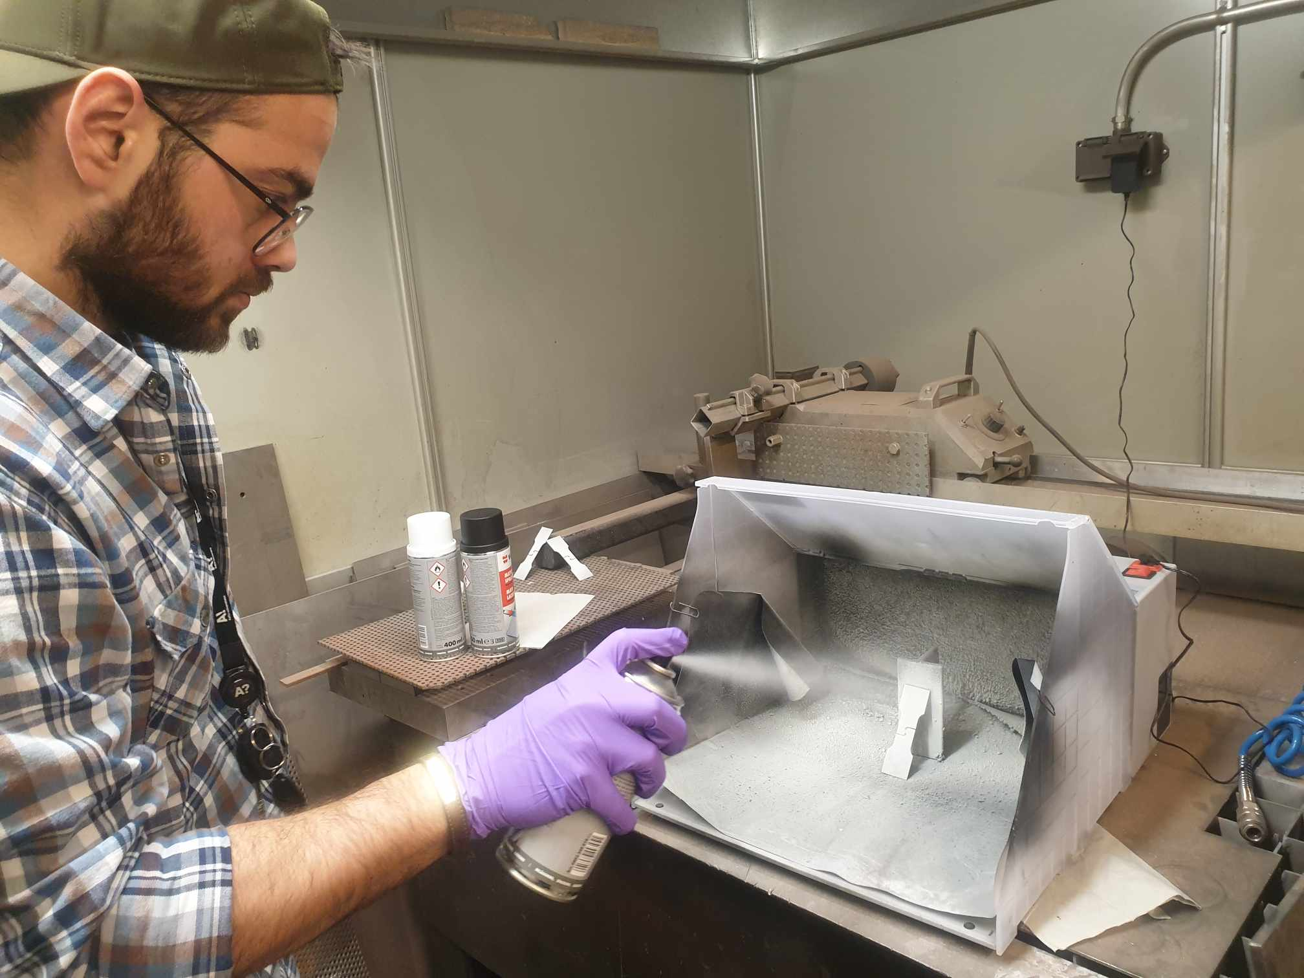

Next, we use black paint to spread intermittently on the specimen to make random noise speckles on the surface. We need to make sure that the speckles are well distributed along the surface without any dense or sparse area of speckles. After painting, it is extremely crucial that we do not touch the middle part of the specimen, or we would ruin the images later during DIC.

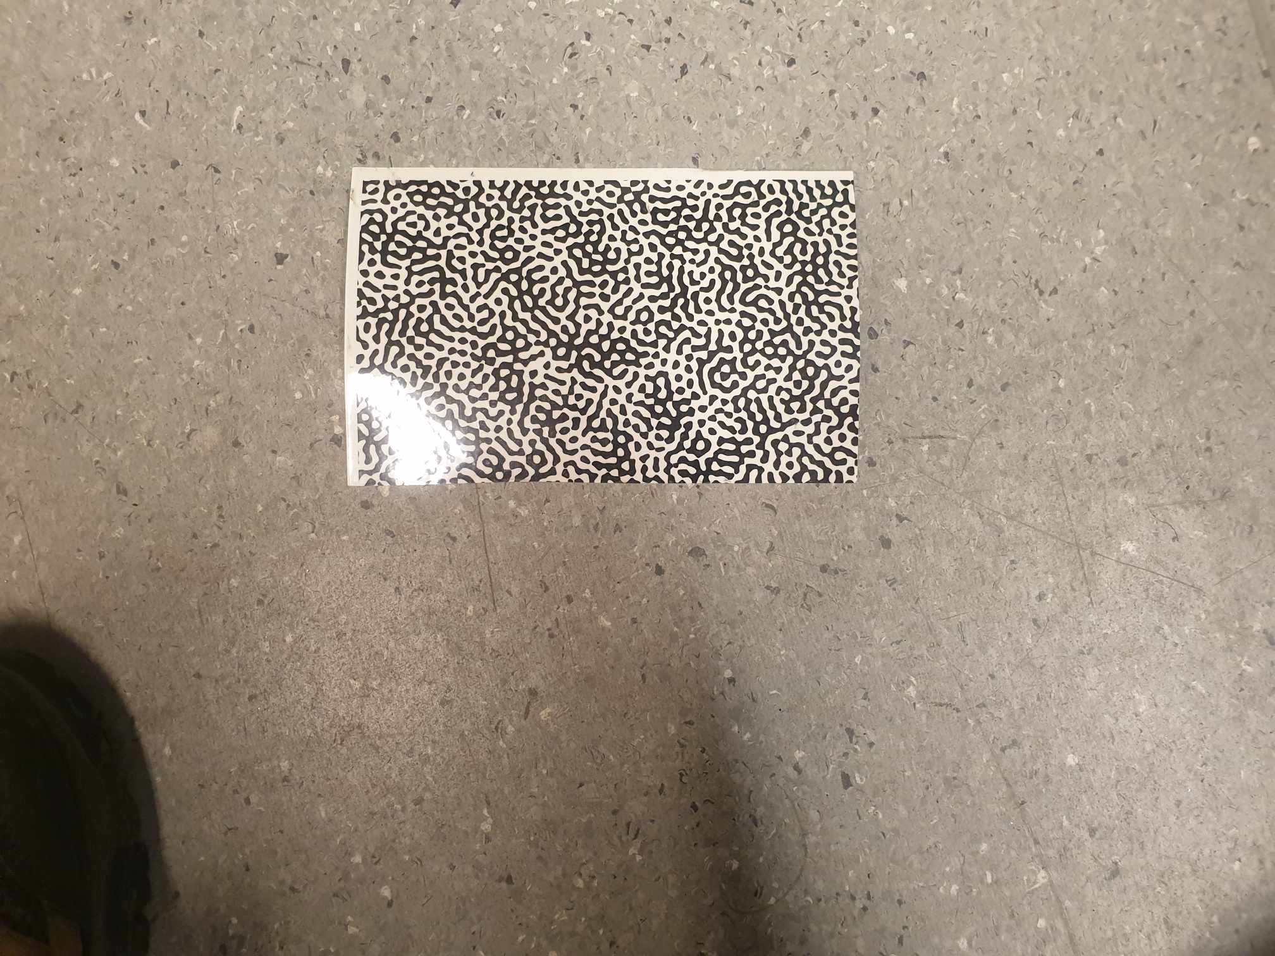

Besides using paint, we can also use computer numerical patterns, which can be glued onto the specimen. This is more common for larger machines or specimens where using paint is wasteful.

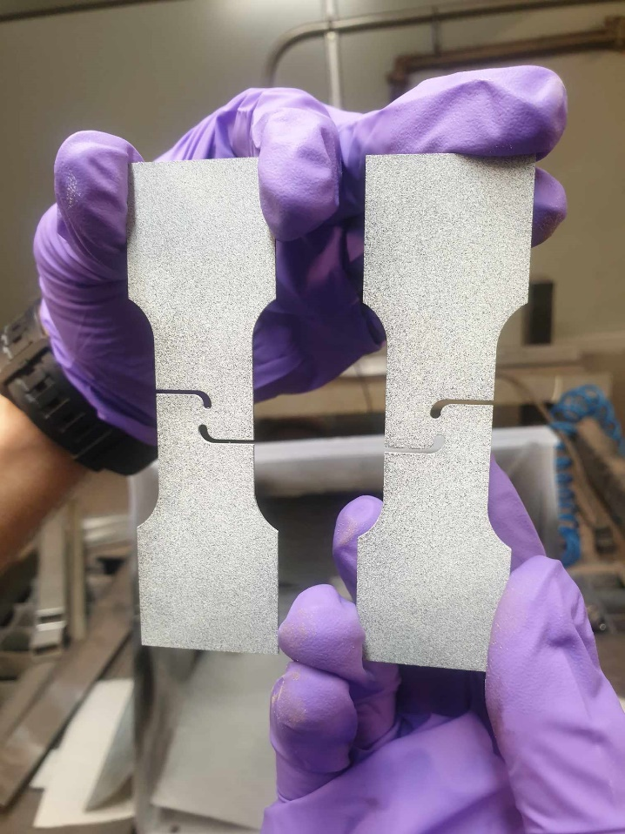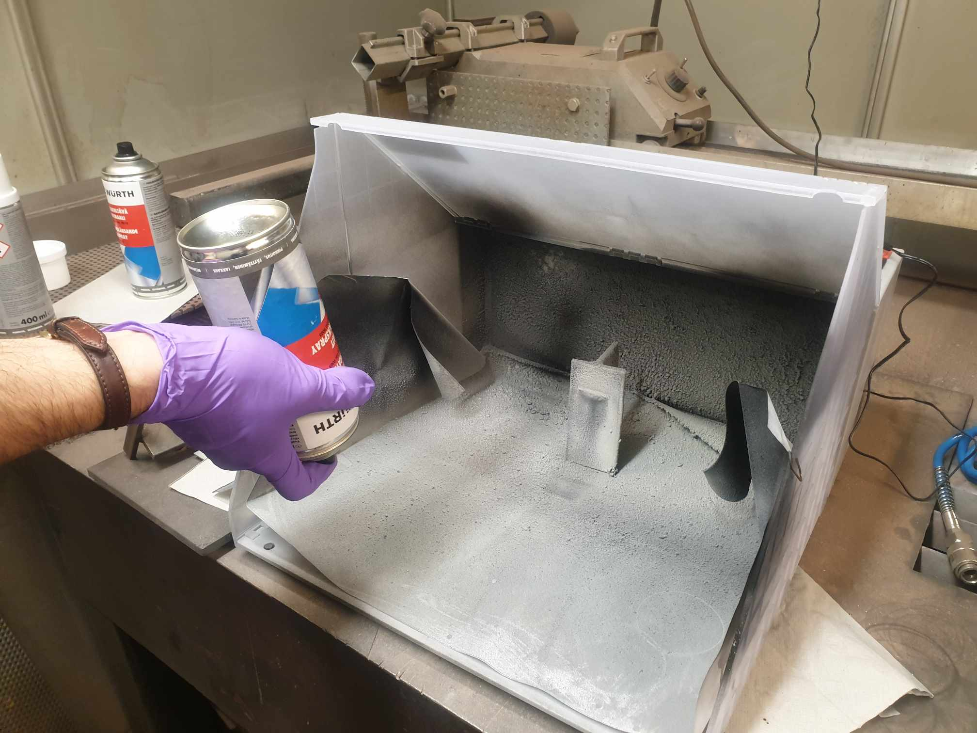

Comparison: on the left is bad patterns and on the right is good pattern for the two specimens

This is because the left specimen has too dense speckles at the center and sparse speckles at the rear end of the grip section. After we use paint, we need to press the bottle upside down and press the button to spurt out paint until no paint comes up to clear the nozzle of the paint. This would help make the paint bottle last longer without becoming stuck at the nozzle

# DIC testing: Recording images during tensile test

## 3.1 Camera equipment setup

The DIC setup involved the use of Vic Snap-9 for capturing images and TextXpert II for conducting tensile tests. For each geometry, there are 3 directions: RD, TD and DD, and for each direction, there are 3 specimens to check their result repeatability, so we have 9 specimens for each geometry (SDB, NDBRx, CHDx, SHx) for DIC testing.

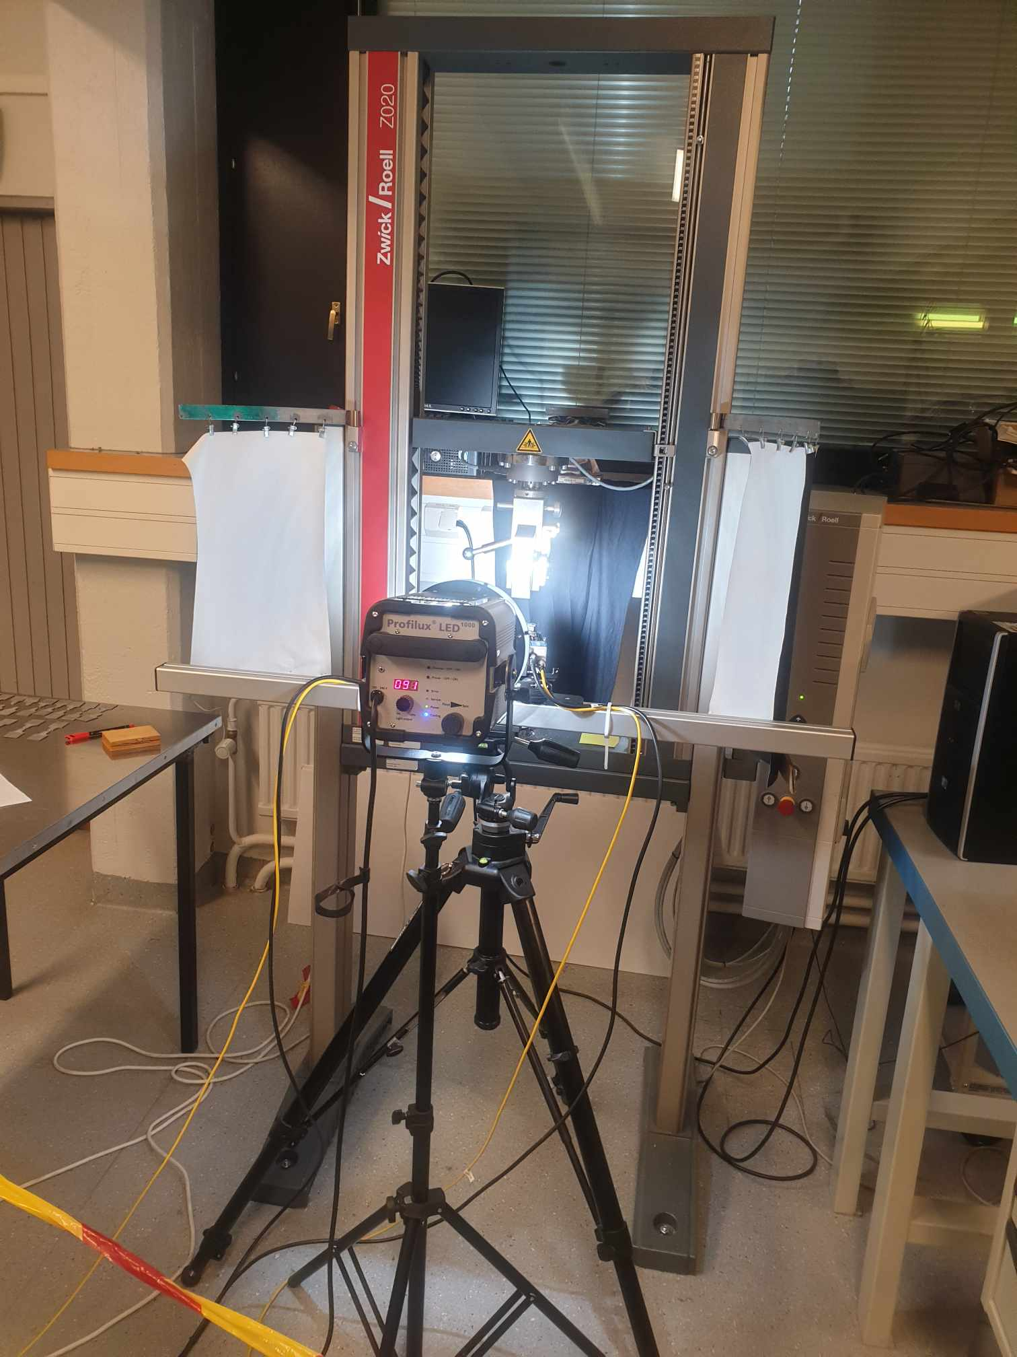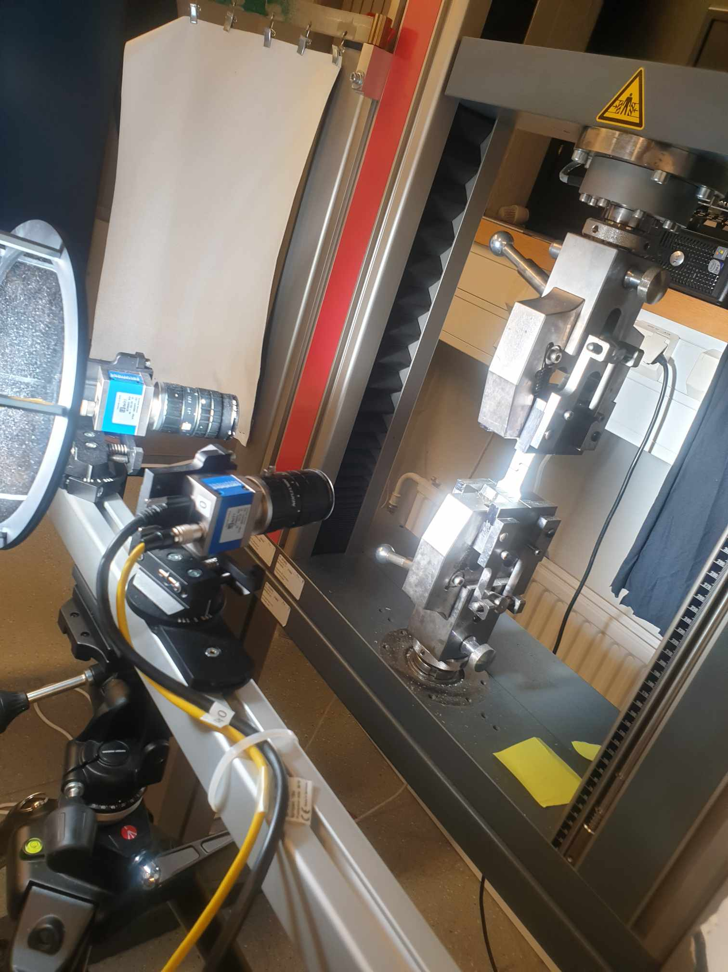

This is the full setup of the DIC, which features two cameras looking at the specimen from different angles. If there is only 1 camera, we can only capture two dimensional changes. However, having two cameras can help us capture changes in thickness. This could be important to calculate thickness -related properties such as R-value. There is a machine box behind the computer monitor. This is the machine that takes images and stores them for Vic Snap software. We should turn the box machine on and let it warm up for a moment. Now on Vic Snap main screen, there are two black boxes, which correspond to black curtains behind the DIC machine. However, if the machine is not warmed up then the screen is totally white (the two cameras show nothing). Later on, when we postprocess the images, two images would be combined, revealing changes in thickness

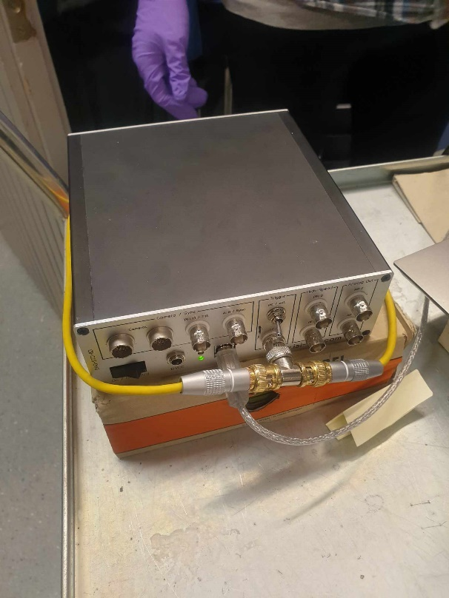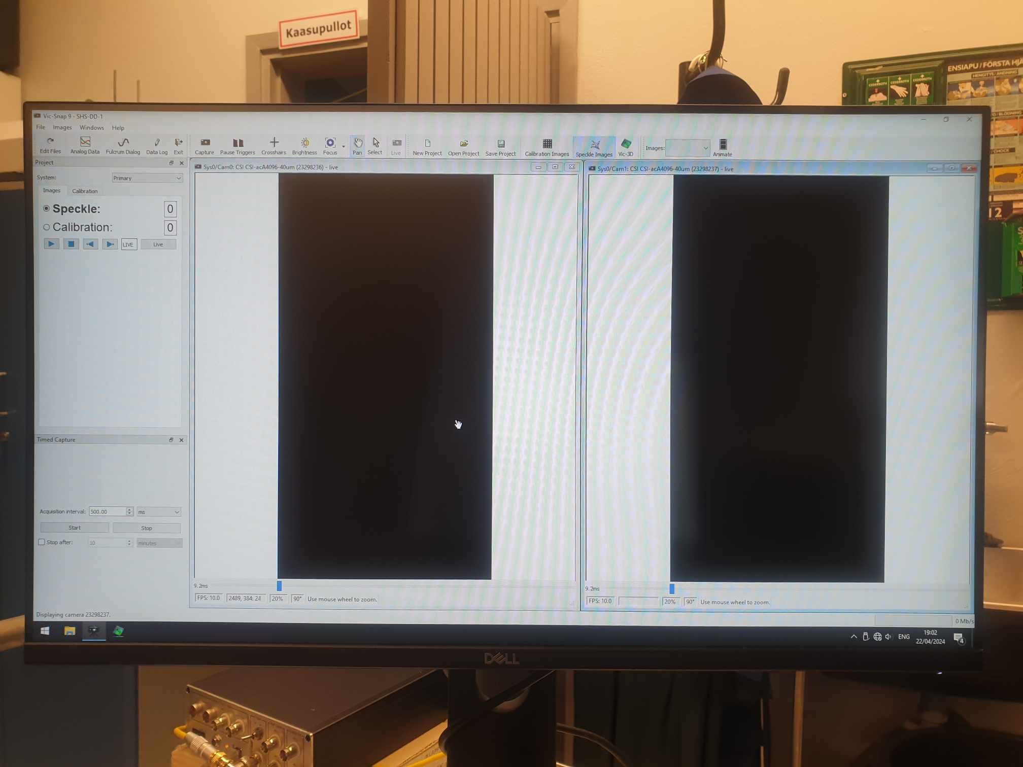

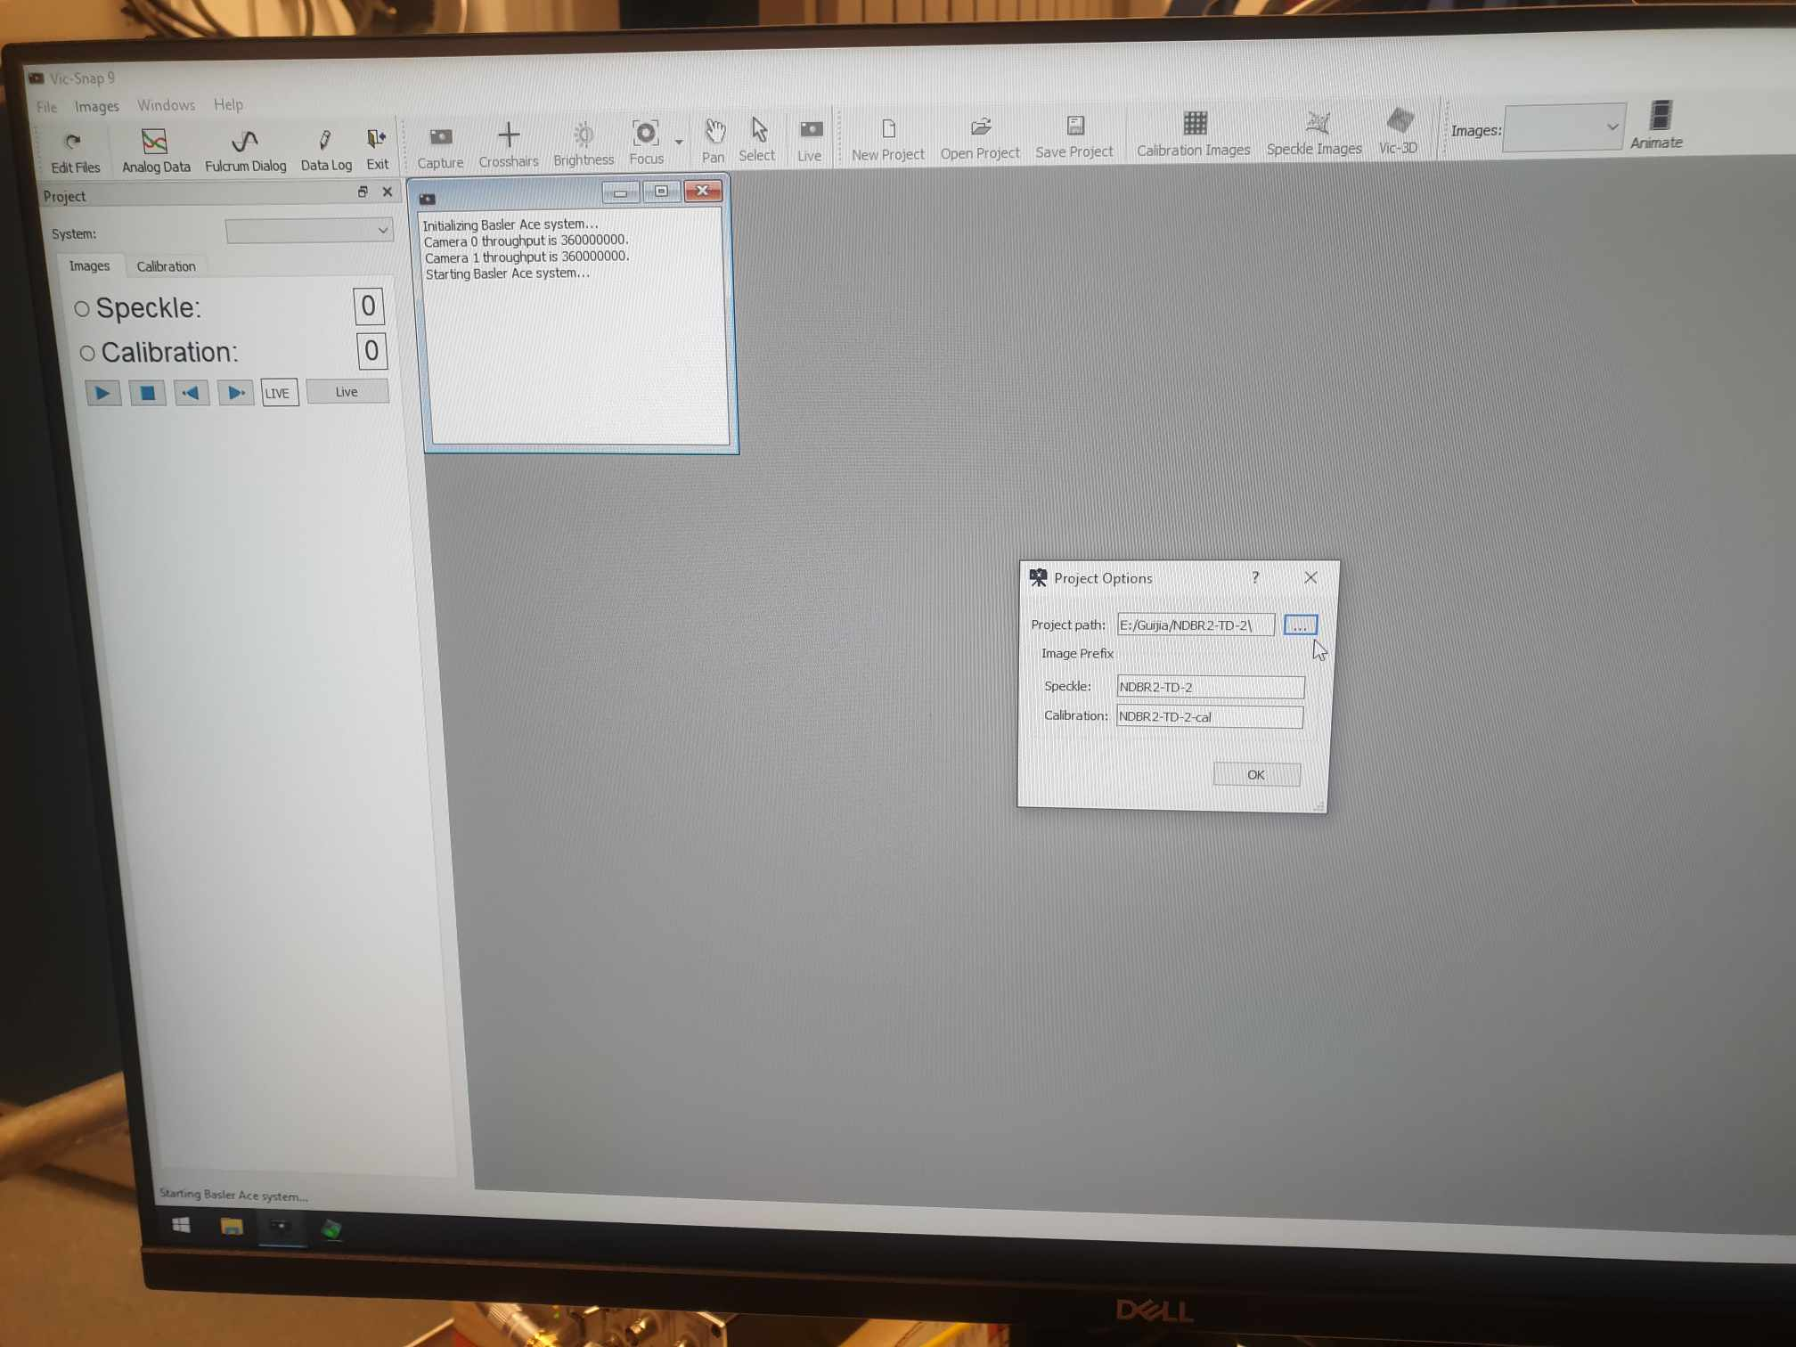

When we first open Vic Snap software, we would see two options, speckle, or calibration options.

* For Speckle option: the cameras would take images taken from the specimen. This is what we choose in this case, since we are sure that the camera has been well calibrated.
* For Calibration option: takes the pictures of a certain fixed speckle pattern (maybe around 30 pictures) and save them. They can be used later to calibrate devices (such as in Vic 3D)

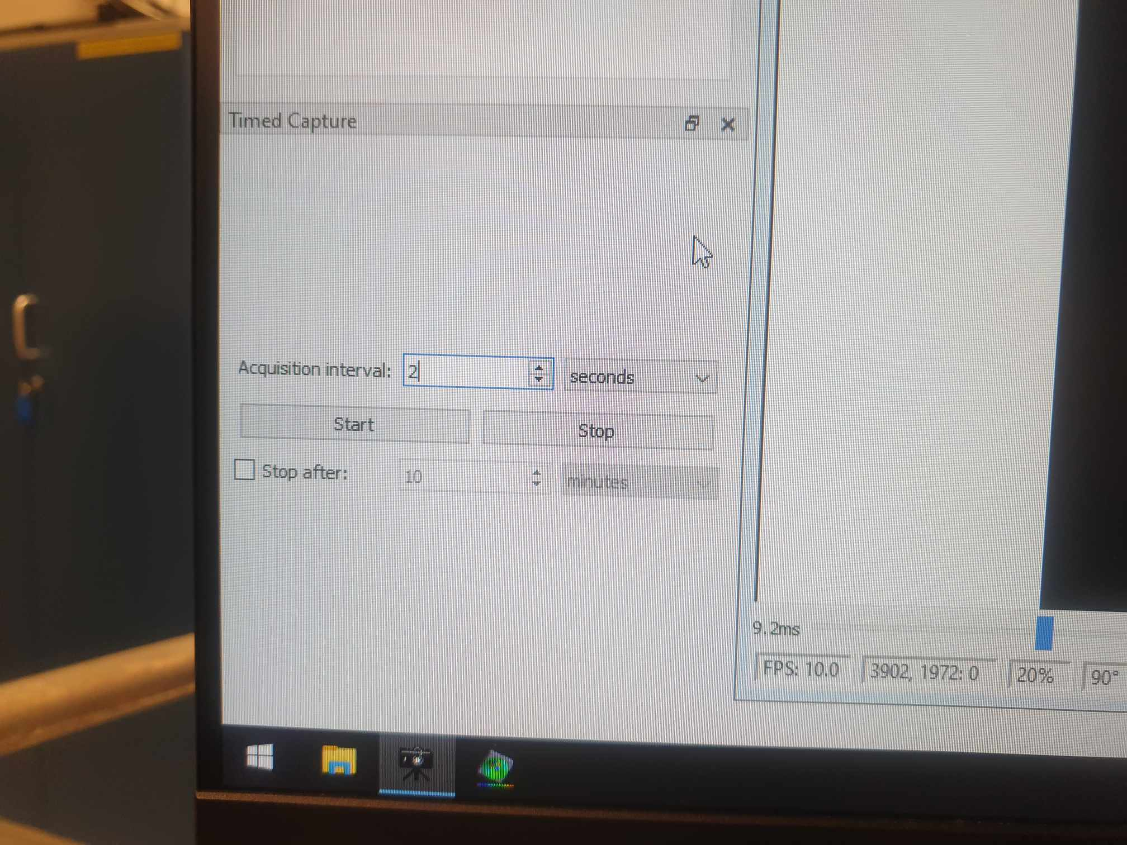

Then, we need to define acquisition intervals, which tells how often the camera should take the image of the specimen. We choose seconds for acquisition interval as it was the unit of time used by the tensile machines, so it is more compatible if we choose seconds for images as well. In this case, the machine would take a picture once every 2 seconds.

After we have turned on the cameras, it is time to set up tensile test options, which are controlled by the TestXpert II software.

## 3.2 Tensile test setup

When we first open TestXpert, we can see all force-displacement curves data of DP800

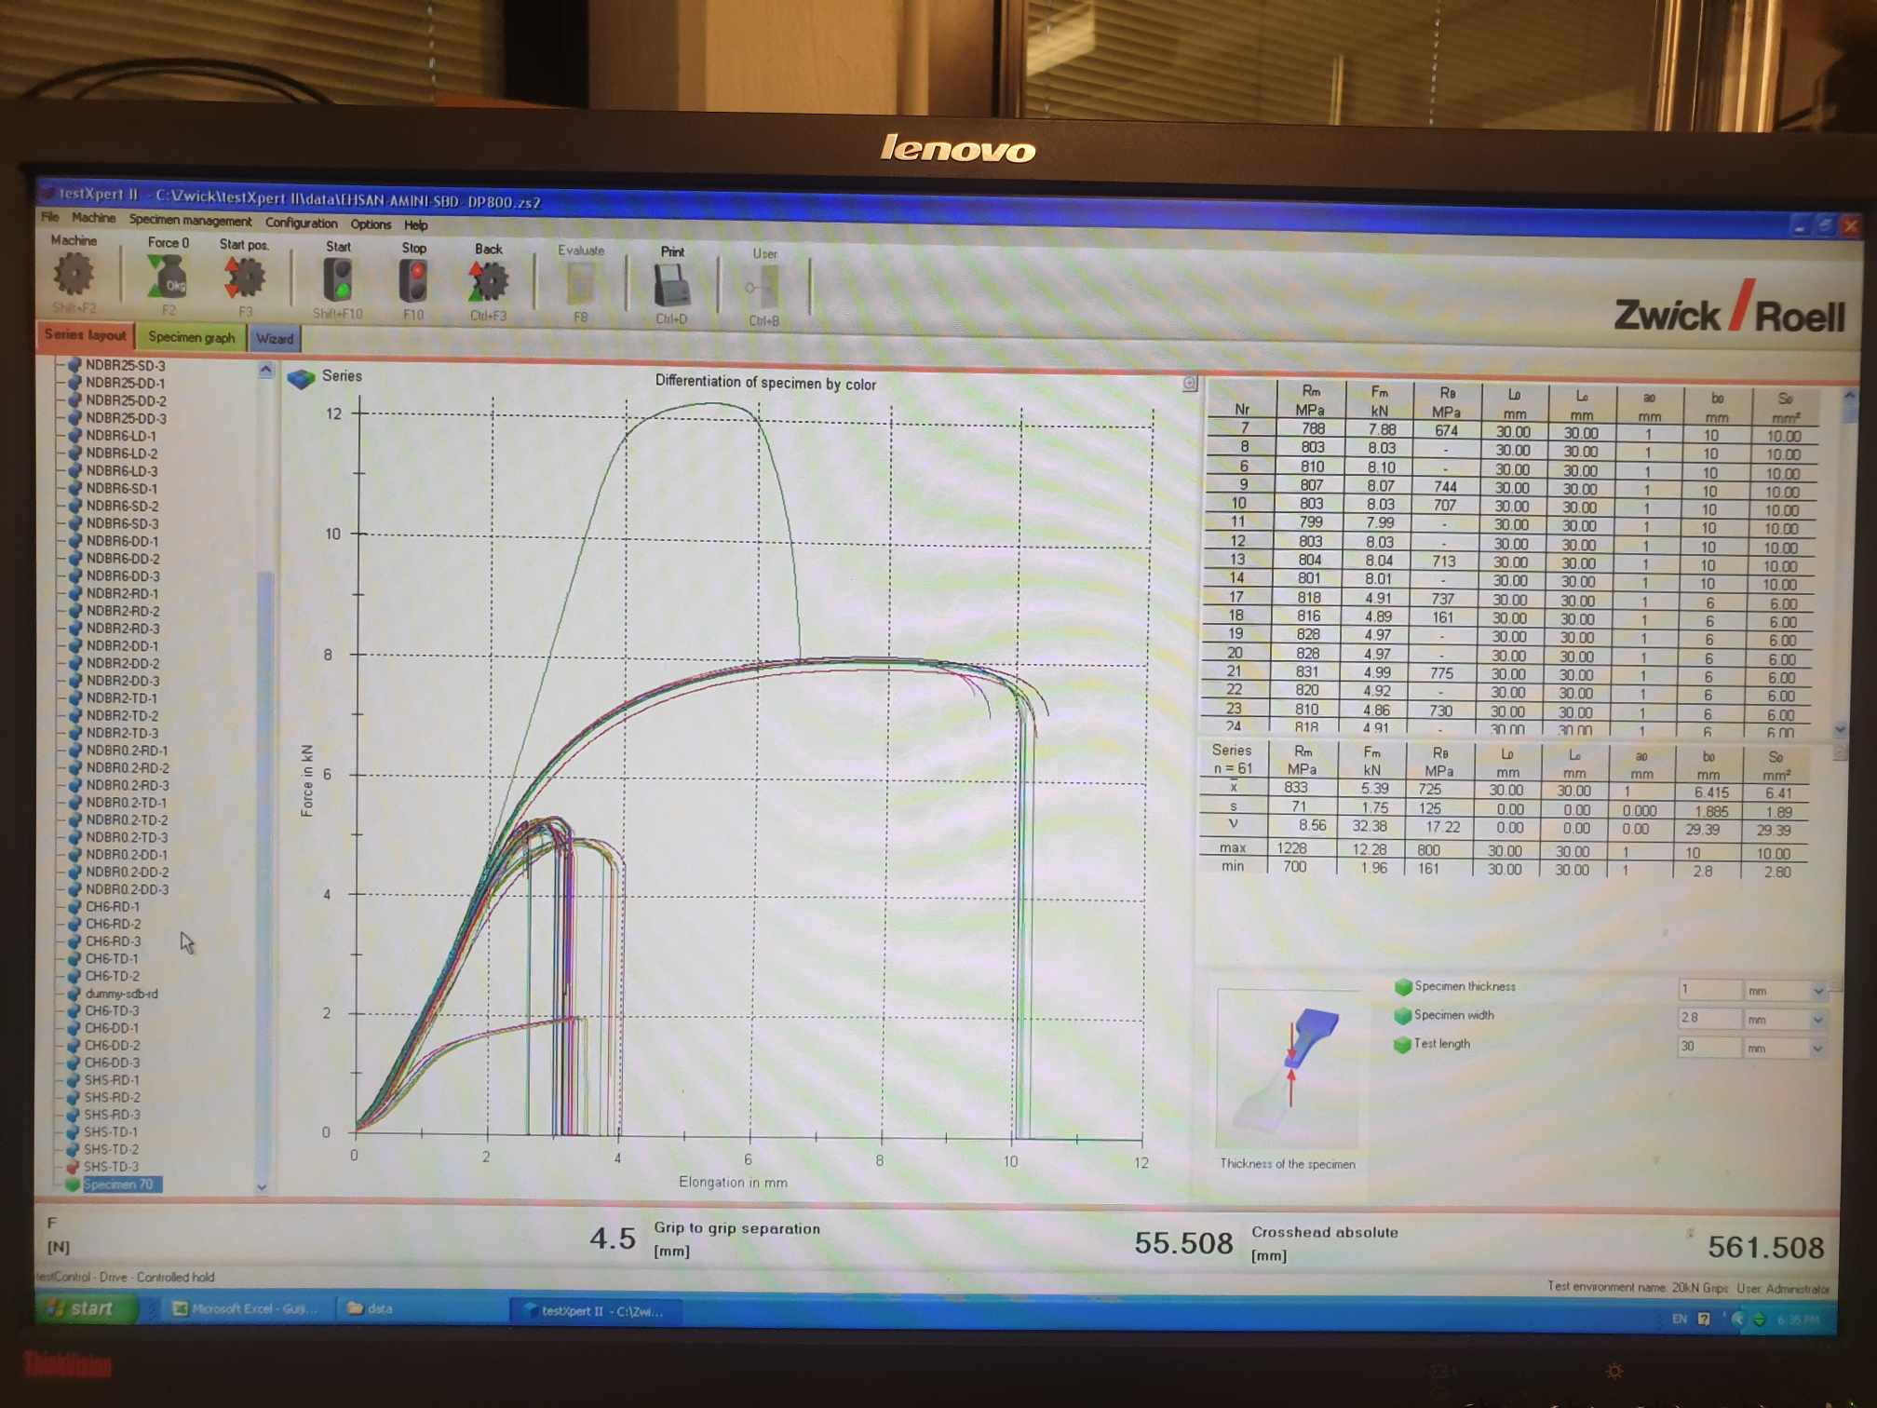

Then we click on the blue Wizard tab to define the settings for tensile test. We open Preload tab

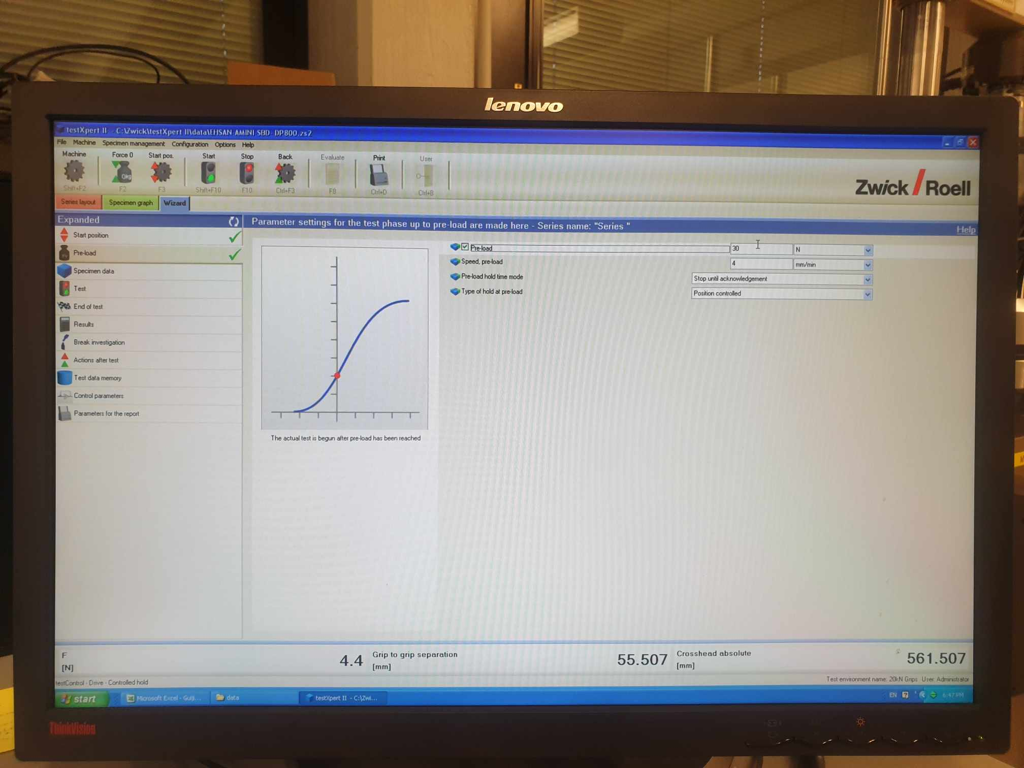

The purpose of the preload is for the machine to tightly grip on the specimen’s gauge firmly. This is because without Preload, there is unwanted data later such as vibration or unwanted displacement of the specimen from its mounted position.

The amount of preload is very important. For SDB DP800, it usually fractures at 800 MPa (or 8kN for SDB specimen). Therefore, we choose a preload of around 15 MPa as preload, which is adequate (compared to 800 MPa, the amount of preload is very negligible). However, for shear geometry, it will break at much lower stress around 600 MPa (or 1.9 kN), so we cannot put 15 MPa as the Preload now would be significant. Based on some calculations, we see that the width of shear geometry is around 2.8 mm and thickness is 1 mm, so area is around 2.8 x 10^-6 m^2, so we put 30 Newton in the box option.

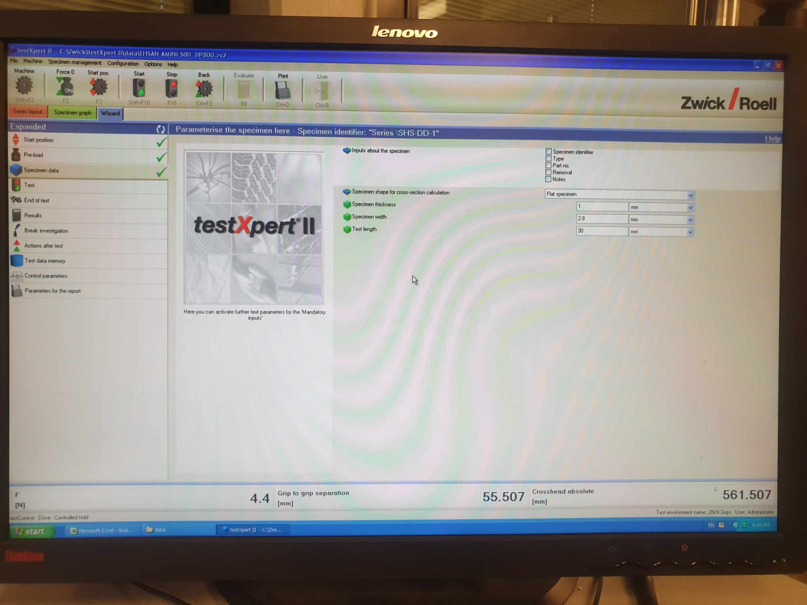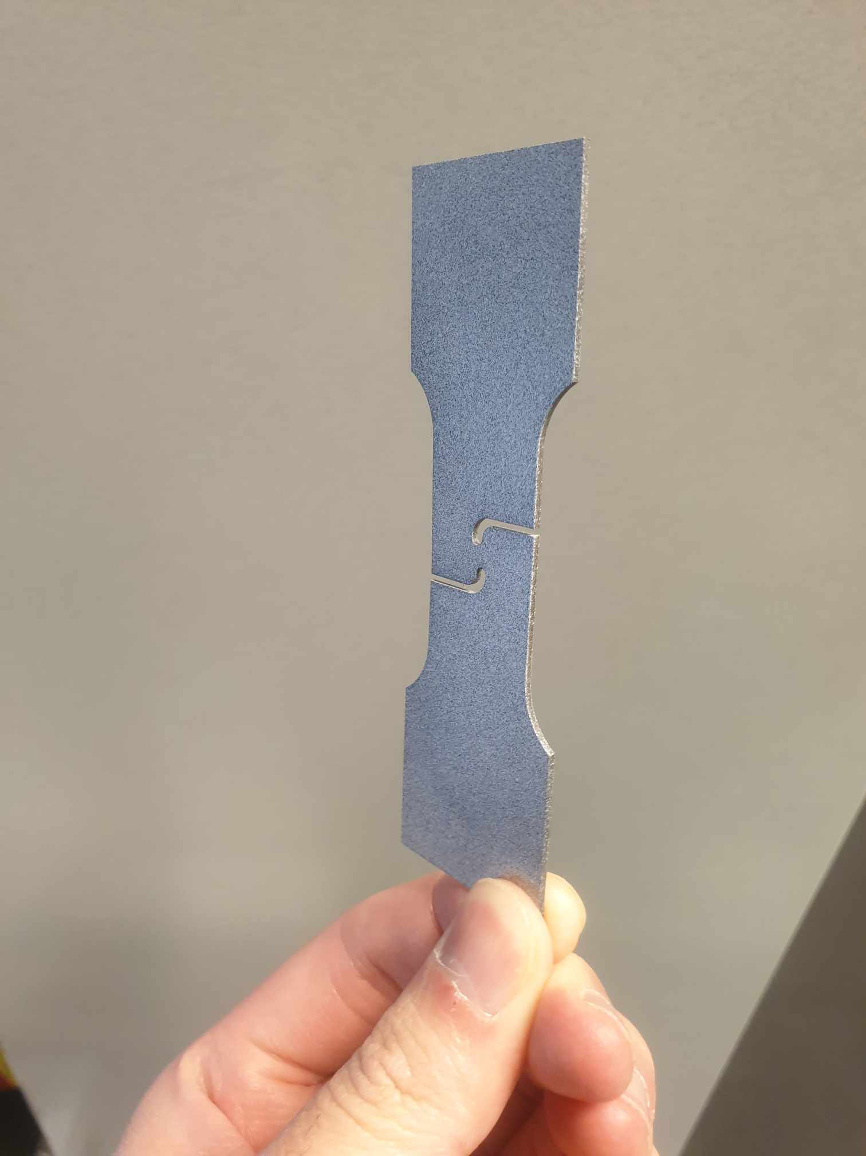

Next, we click on the specimen data tab. In this tab, we only need to define geometry dimensions. For the shear geometry, thickness is 1 mm, width at the middle is 2.8 mm and length is 30 mm.

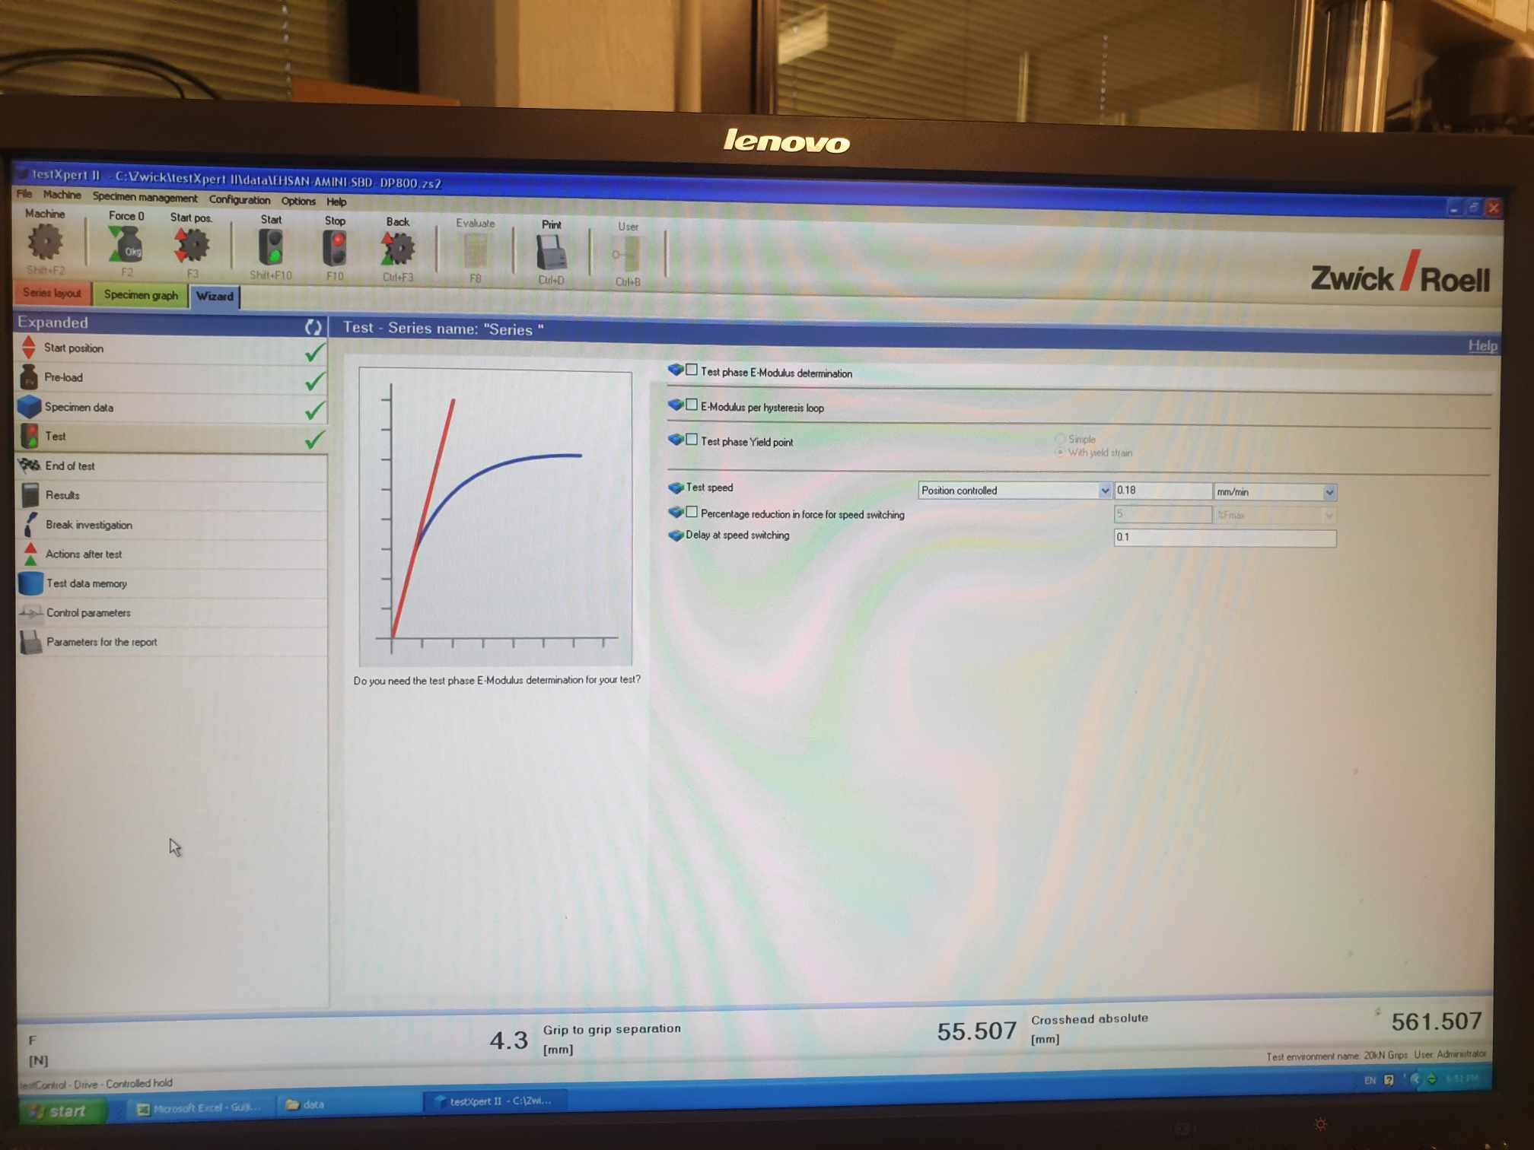

Finally, in the Test tab, the most important information is the Test Speed

For SDB, NDBRx and CHDx specimen, we would use 0.36 mm/min.

For shear specimen, we use 0.18 mm/min (half test speed of other geometries’)

Other tabs (end of test, results, etc), we can let them be their default settings.

## 3.3 Setting up the testing specimen

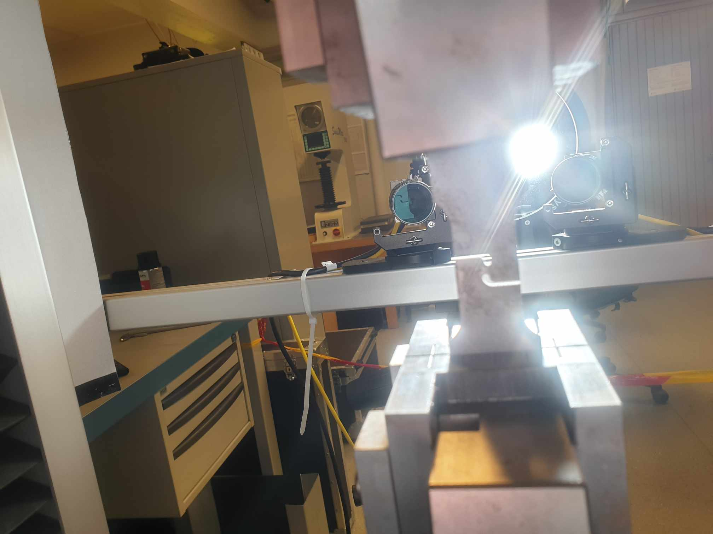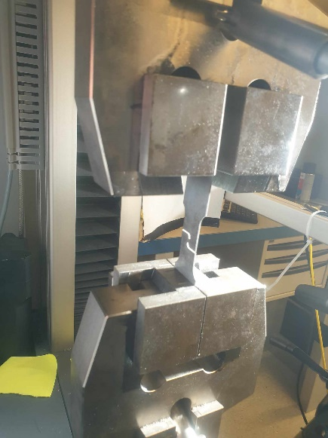

When we put the specimen into the tensile machine, we should position it in exact symmetric position in both X and Y direction. This is because DIC images expect the specimen to be in exact perpendicular positions for highest accuracy of correlation calculation.

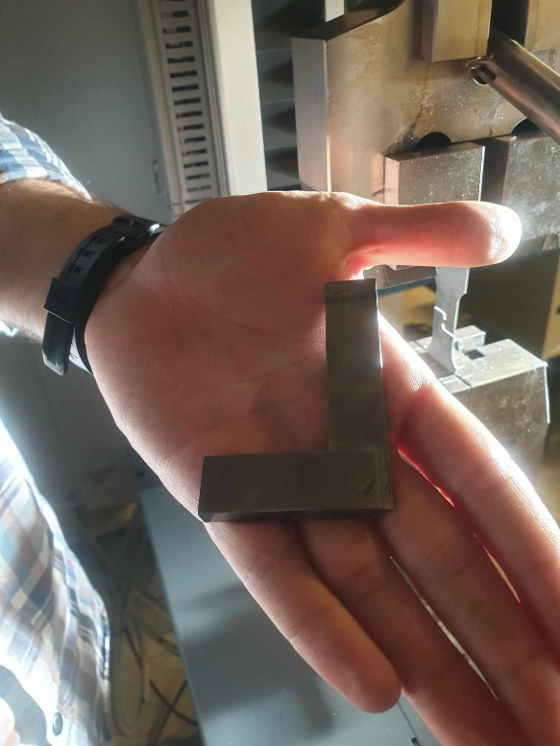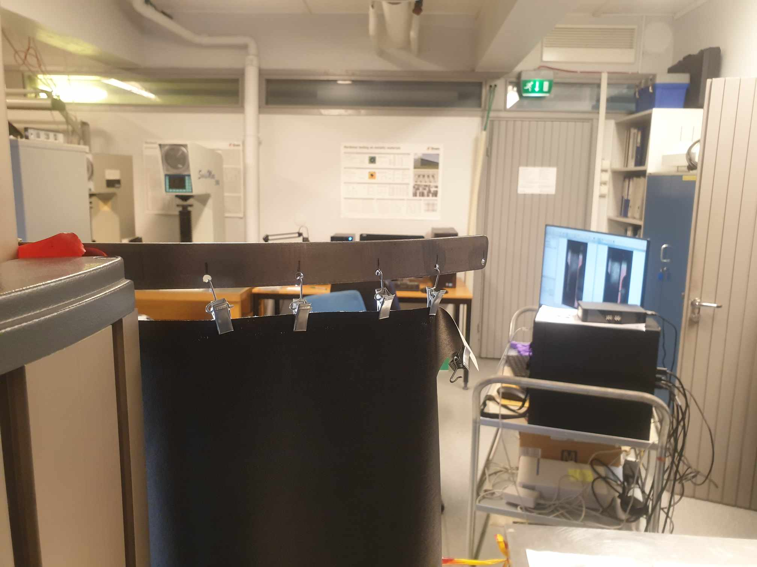

To align better, we can use the perpendicular tool to totally make the specimen positioned vertically. As we fix the position of the specimen, we can also look at the monitor screen to ensure that the perpendicular tool totally covers the gauge portion. After the specimen is totally erected upright, we can start to process on the main screen, which should have two images of the specimen.

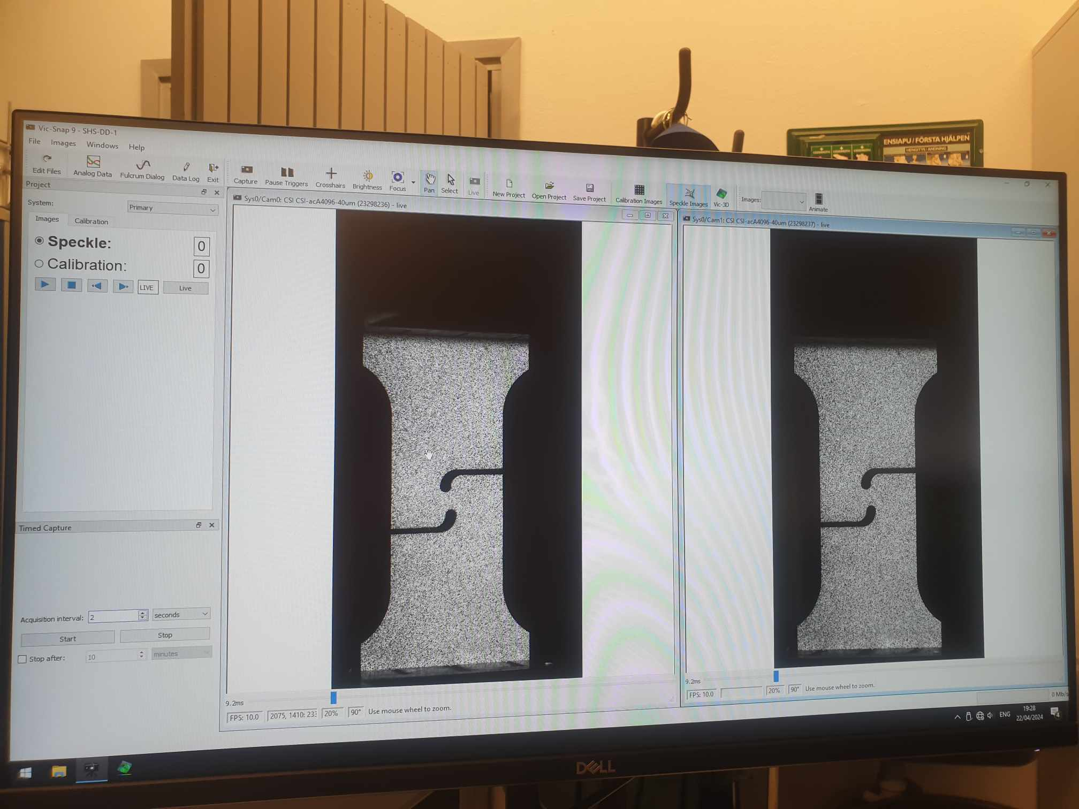

3.4 Images taking with DIC cameras

Now on Vic Snap, we press brightness/or focus button to see the colors. As we look at the color bar, we have the brightness chart ranging from purple (bright) to red (poor). Since most of the specimens are labeled violet and dark blue, it is certain that the paint applied previously is well illuminated enough. If the brightness is poor (yellow to red), we need to do the painting again.

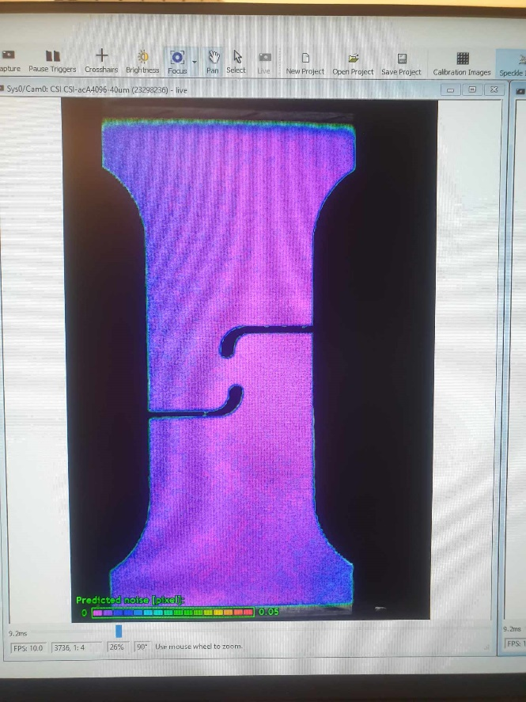

To check the calibration of the camera, we align the crosshairs and zoom in until both cameras focus on the same point. A discrepancy of 4-5 pixels between the cameras is considered acceptable and generally negligible for image analysis. However, ideally, the cameras should be perfectly aligned. If time constraints exist or multiple DIC tests need to be conducted in a short period, extensive calibration for each test may not be feasible.

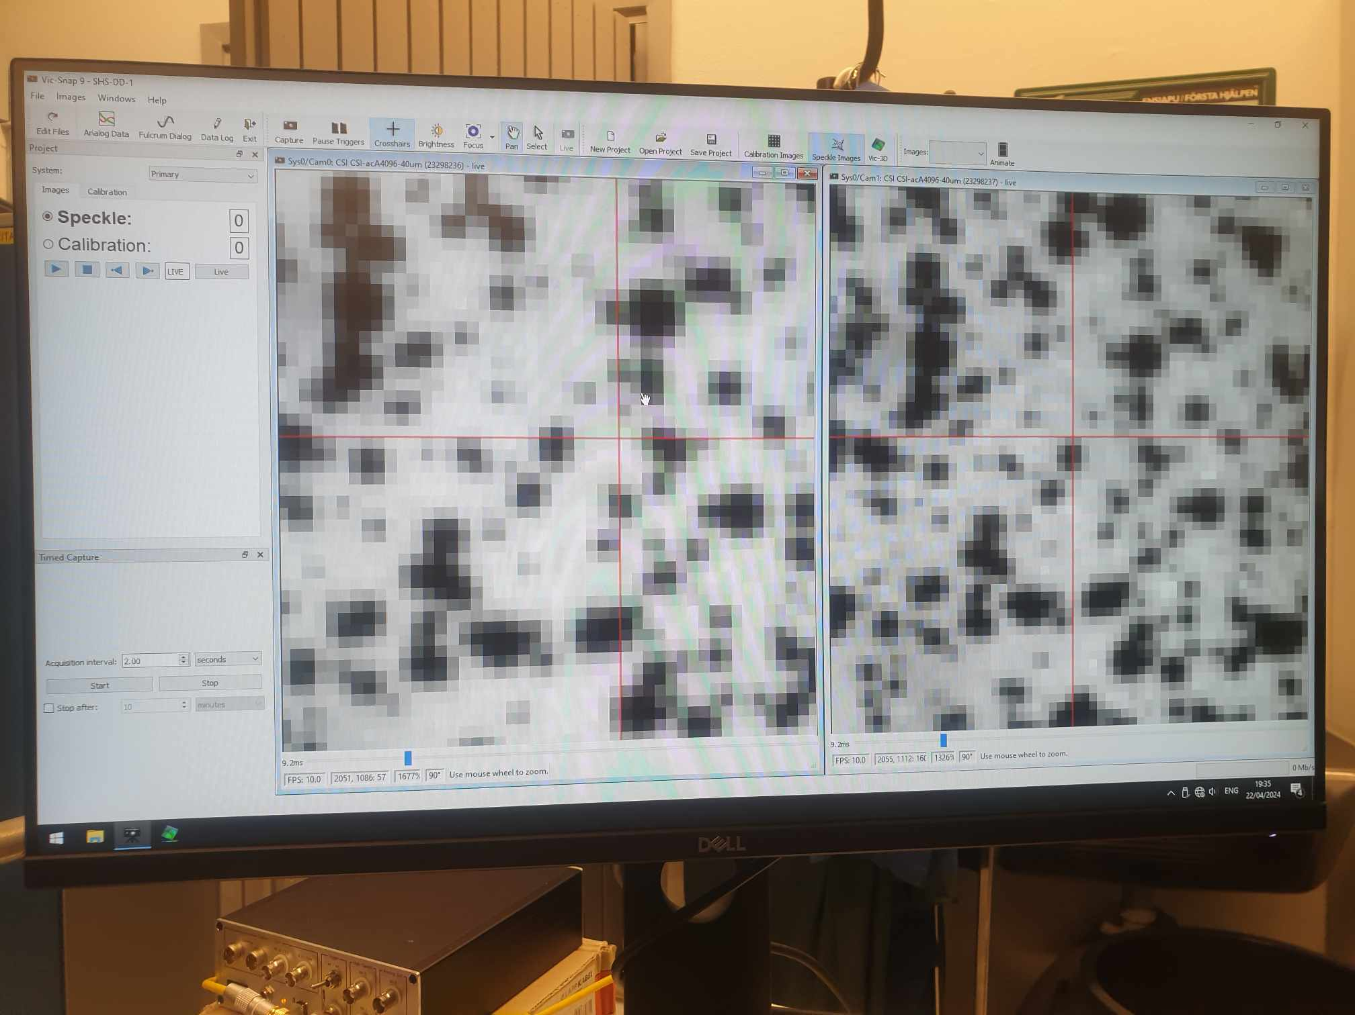

As we zoom in more and more until it stops, the red cross should cross at the same pixel for both images. In this case, we believe the pixel difference is only about 5-6 pixels, which is insignificant. As a result, it is time to start the tensile test (from TestXpert software), and as planned, it initially starts the preloading process

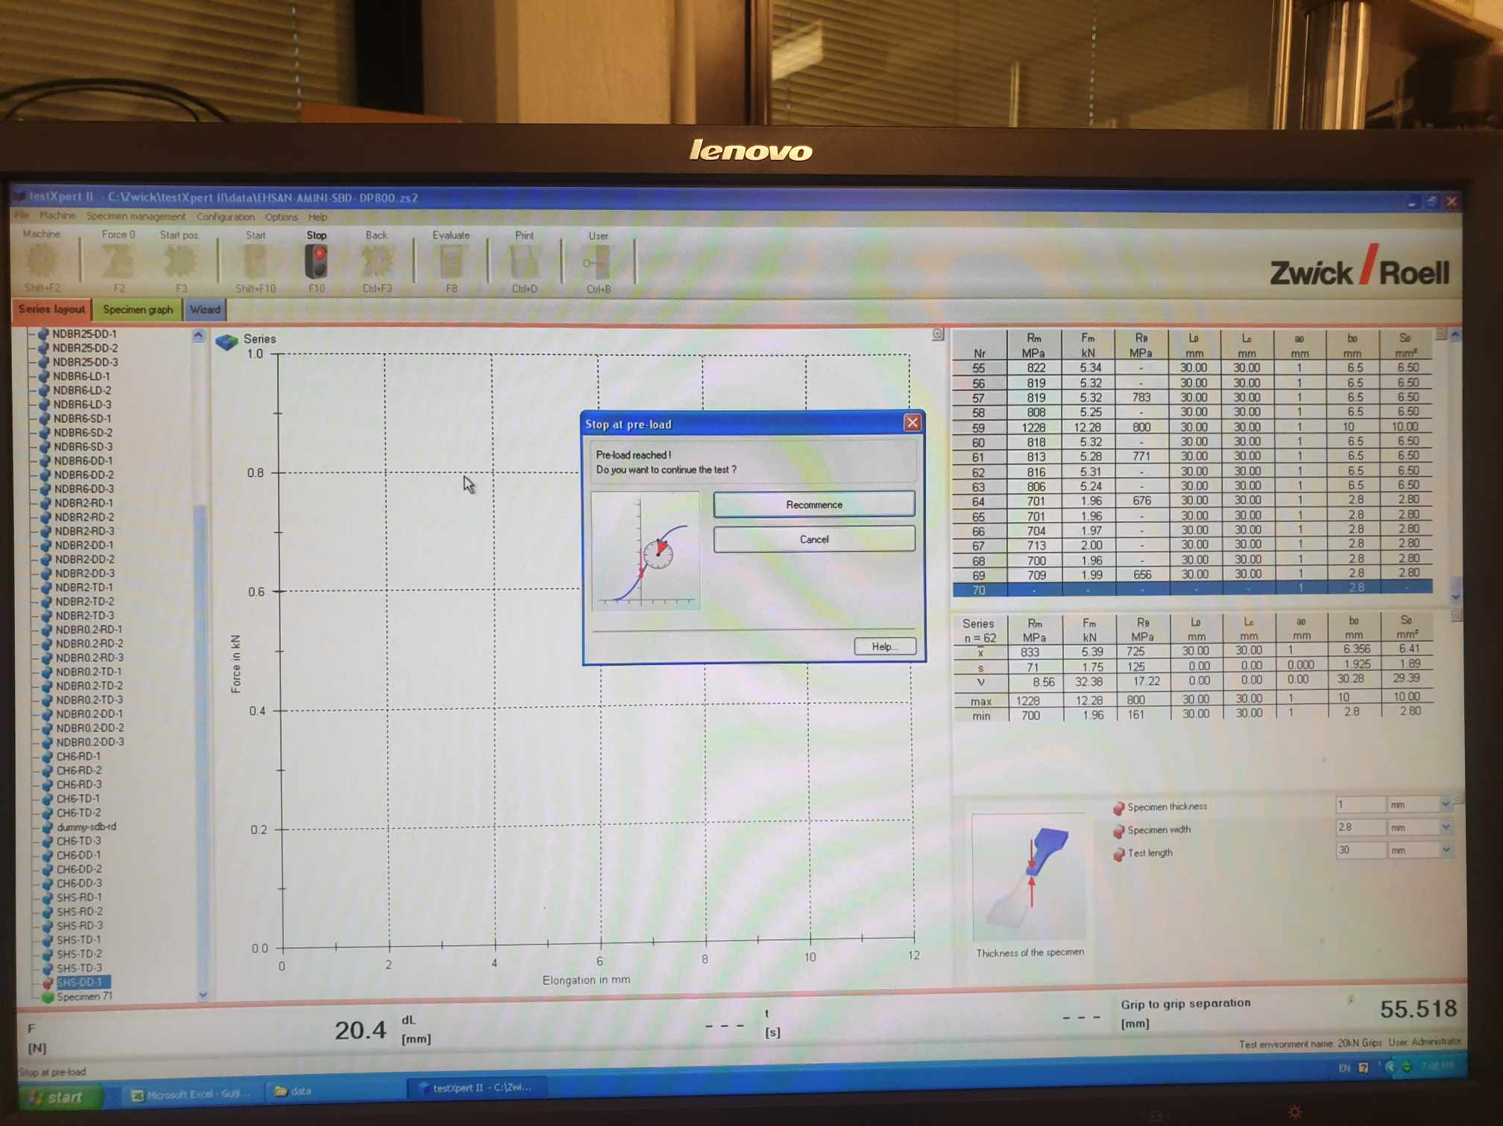

Finally, the DIC machines start to take images (in the image right now, it is 30 images)

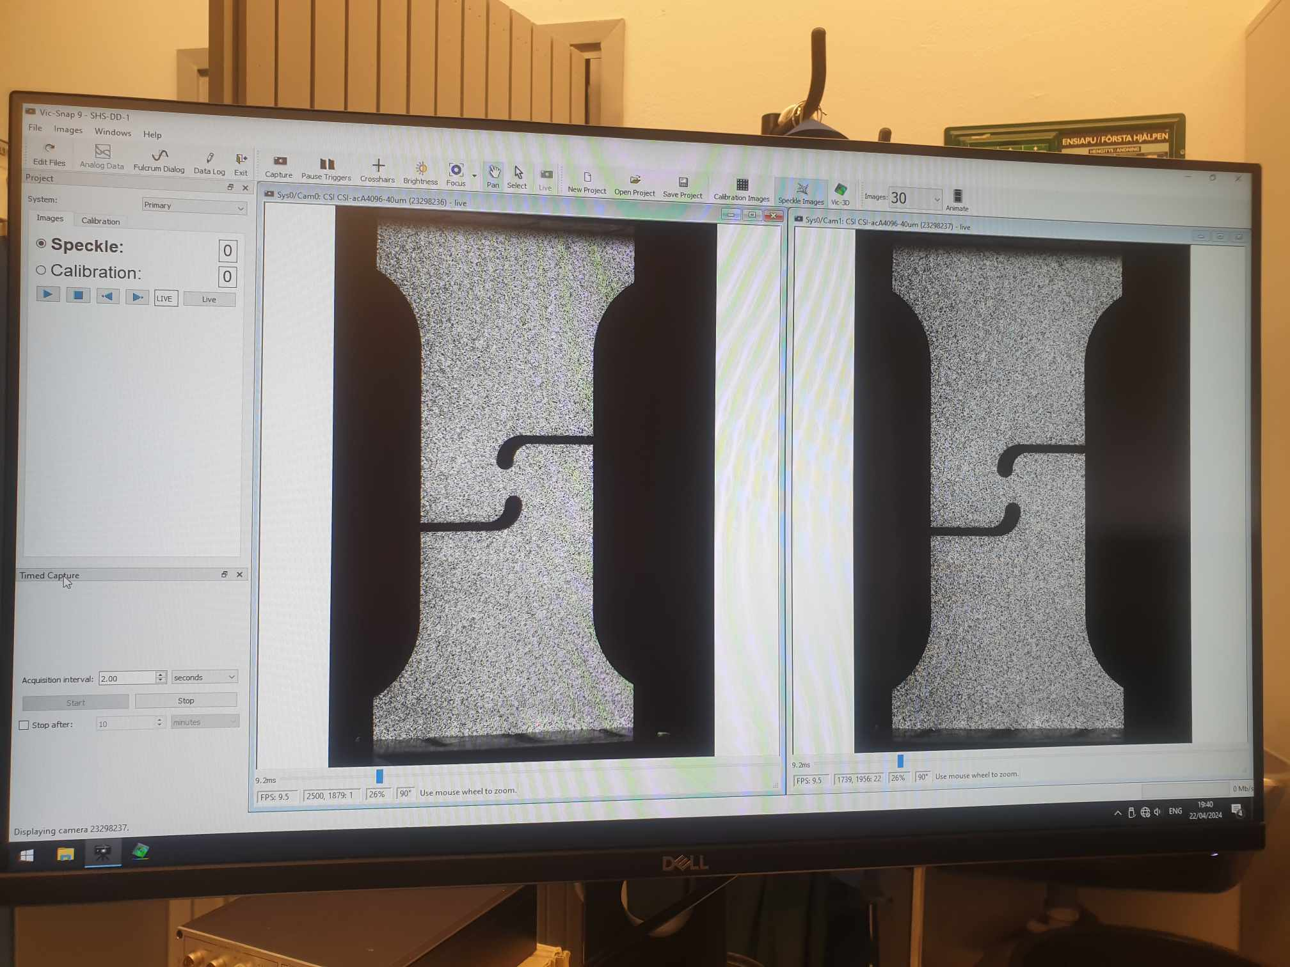

Image acquisition in DIC testing should continue until the specimen fractures. Once the fracture occurs, the stop button should be pressed to halt further image capture. While there is an option to automatically stop after a set period or event, it is important to manually monitor and wait for the actual moment of fracture to ensure all images are collected up to the point of material failure. After the specimen fractures (observable from the images or hearing a cracking sound), we can click the Stop button. The result output is a list of TIF images recorded from beginning until Stop.

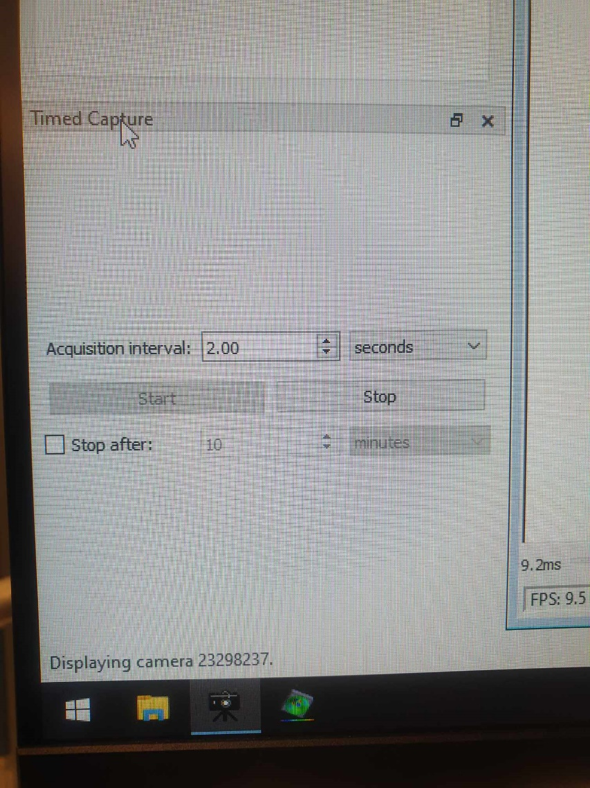

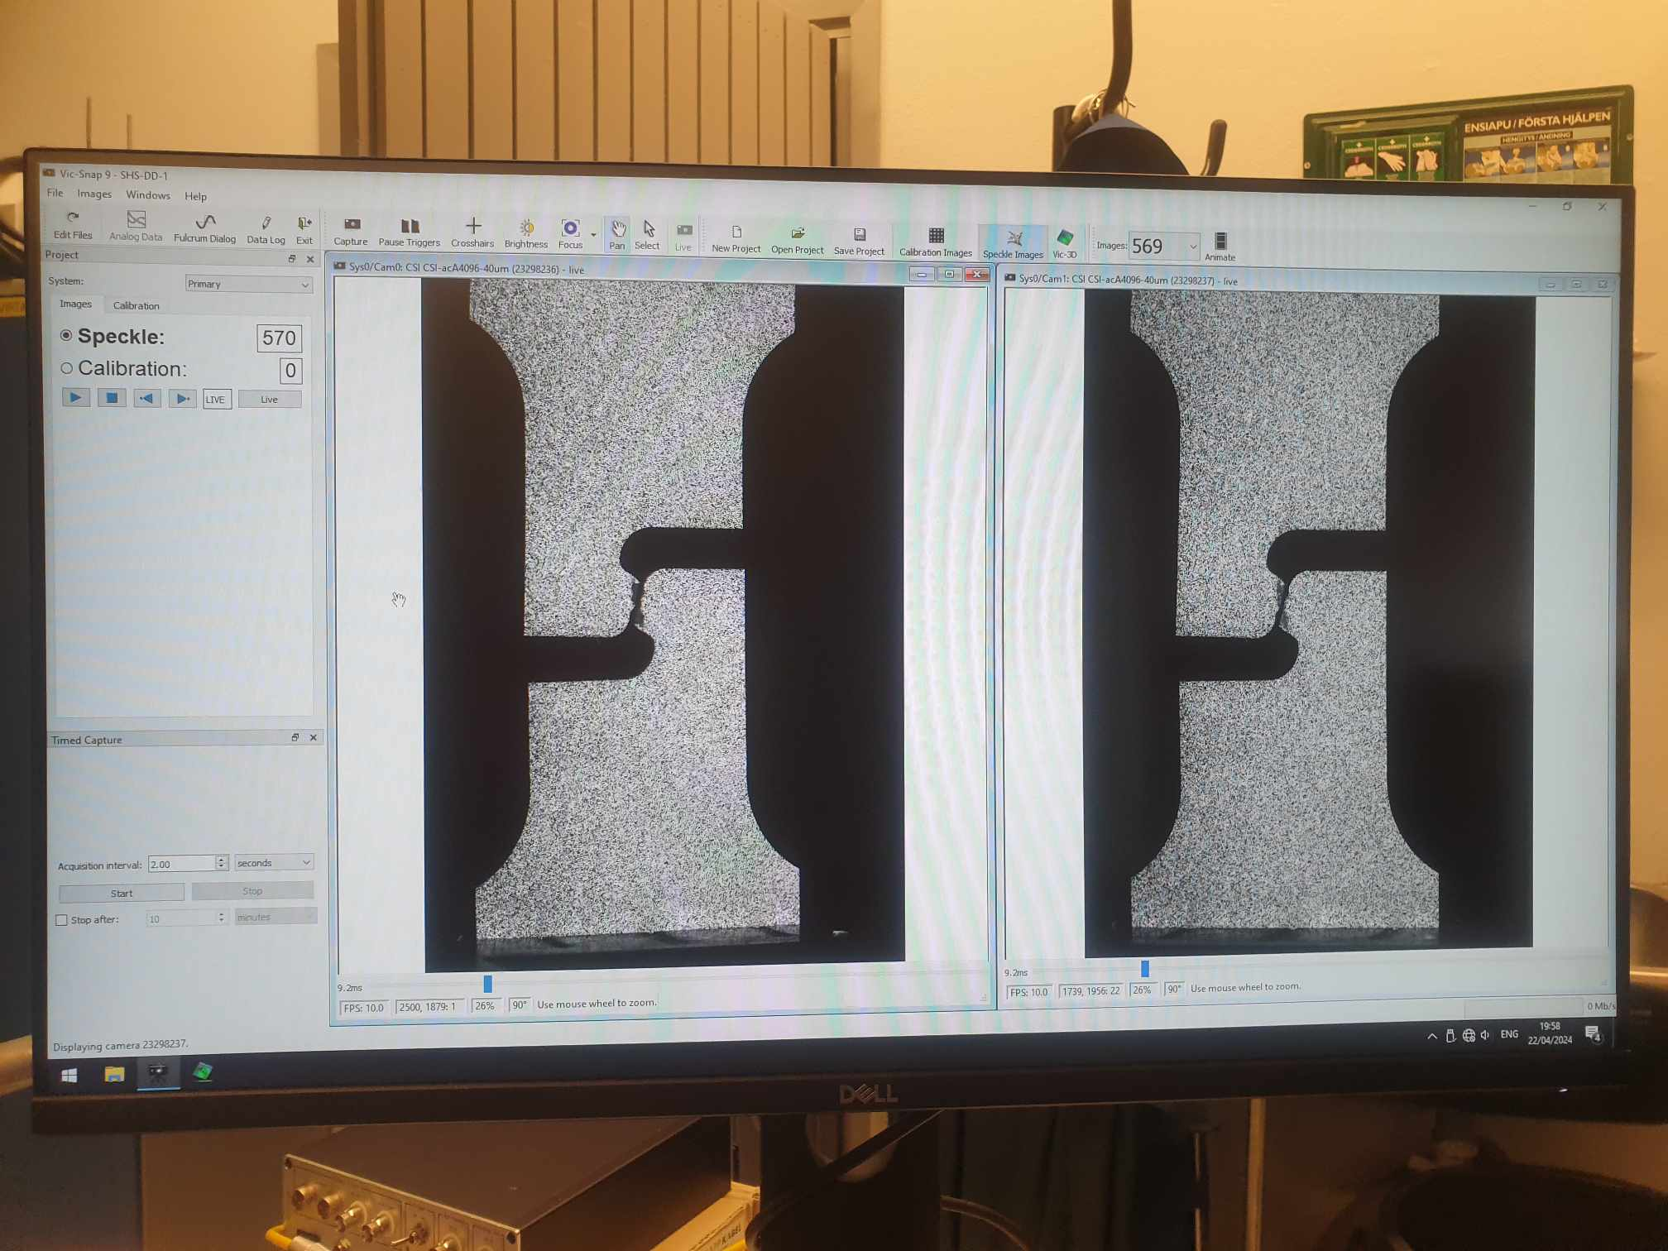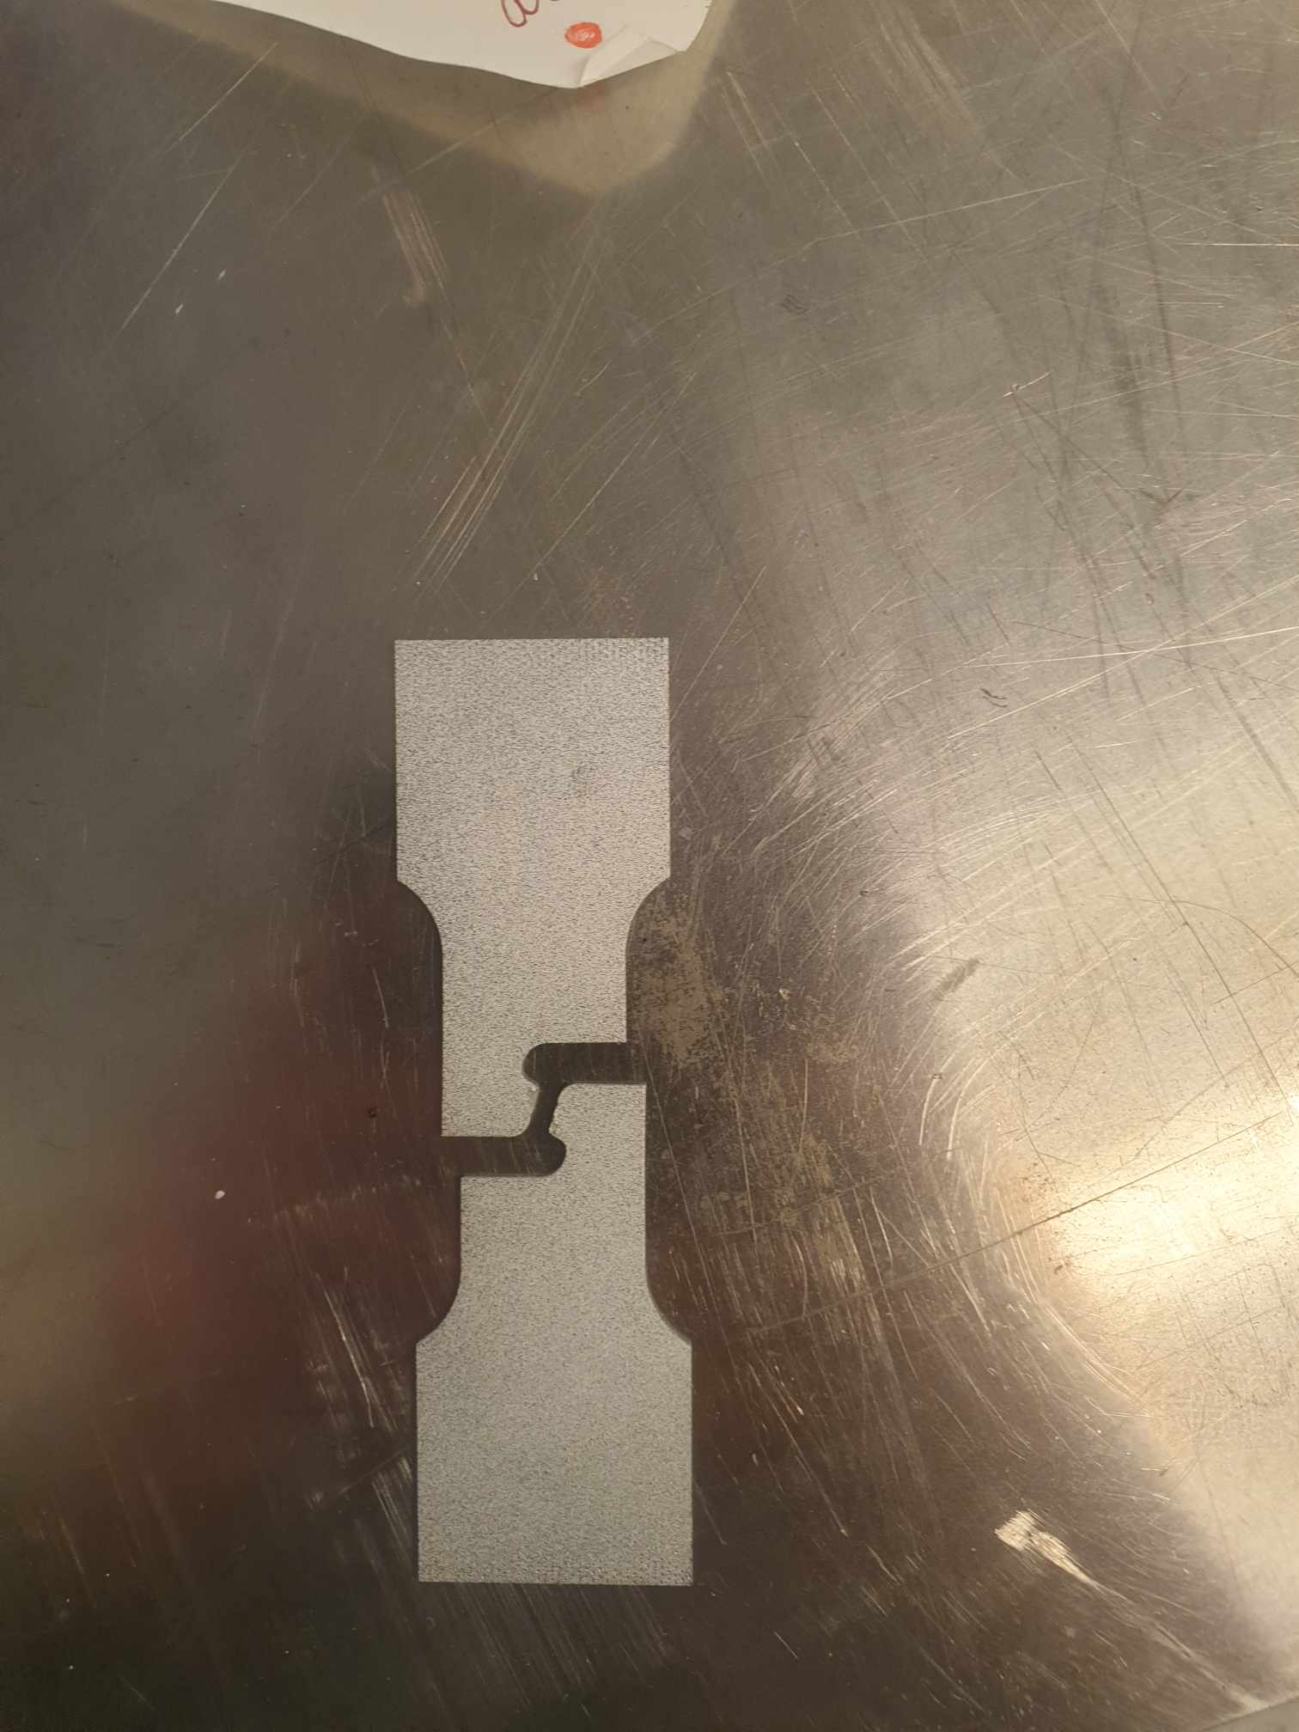

The specimen finally fractures after 569 images. Since each image is 2 seconds, it means shear geometry fractures within 569 x 2 = 1138 seconds. On the TestXpert software, we can also plot the final curve of force-elongation recorded during tensile test.

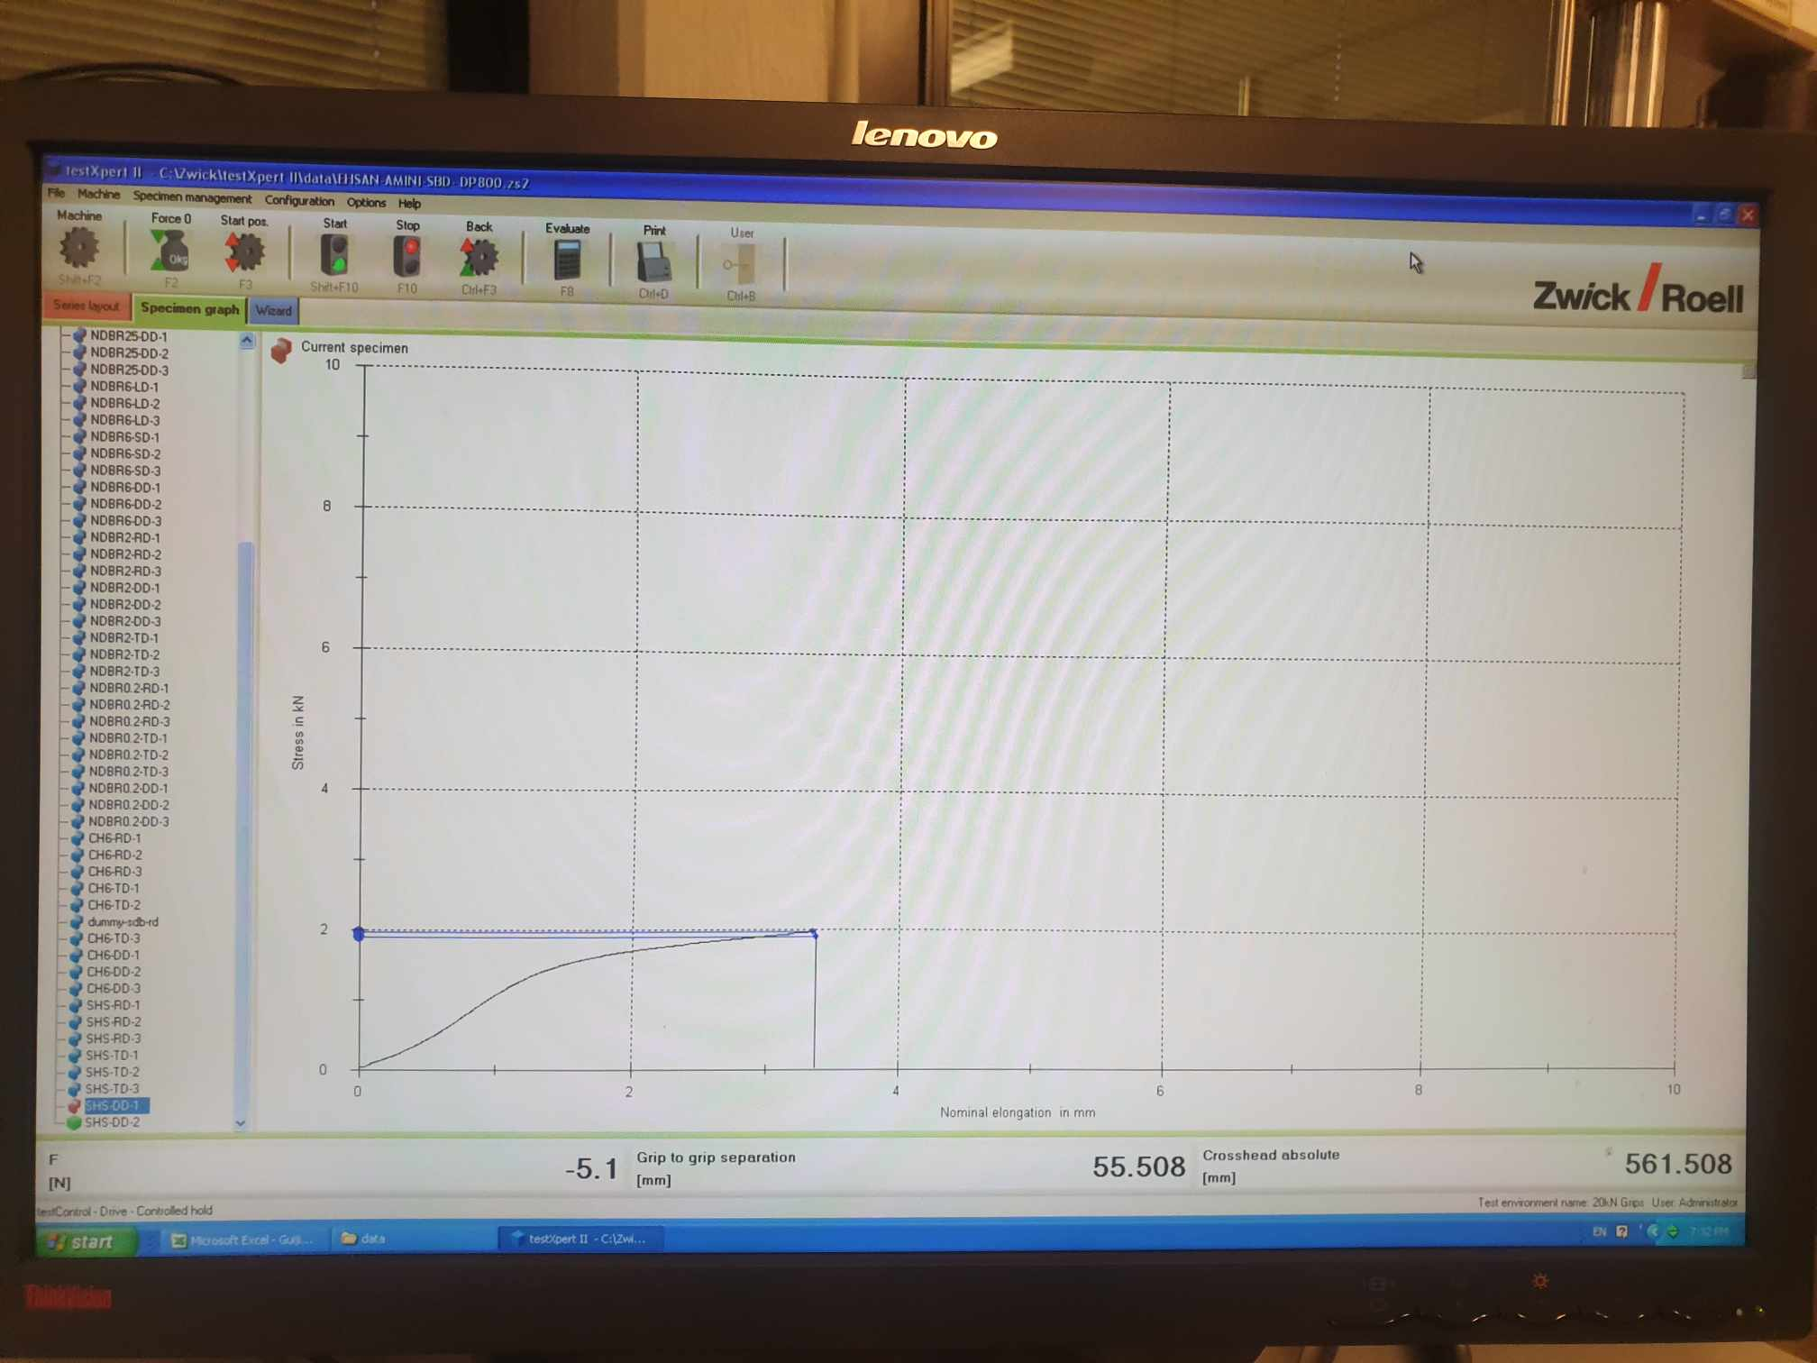

# DIC testing: Postprocessing stage for data extraction

Vic Snap 9 is integrated with the tensile testing machine to capture images from the cameras during the test. These images are stored as a series of TIF files, which maintain standard dimensions for consistency. Subsequently, these images are processed using Vic 3D, a software designed for calculating the correlations from the speckle patterns captured on the specimen. From now, we process on the central hole specimen instead of the shear specimen discussed previously.

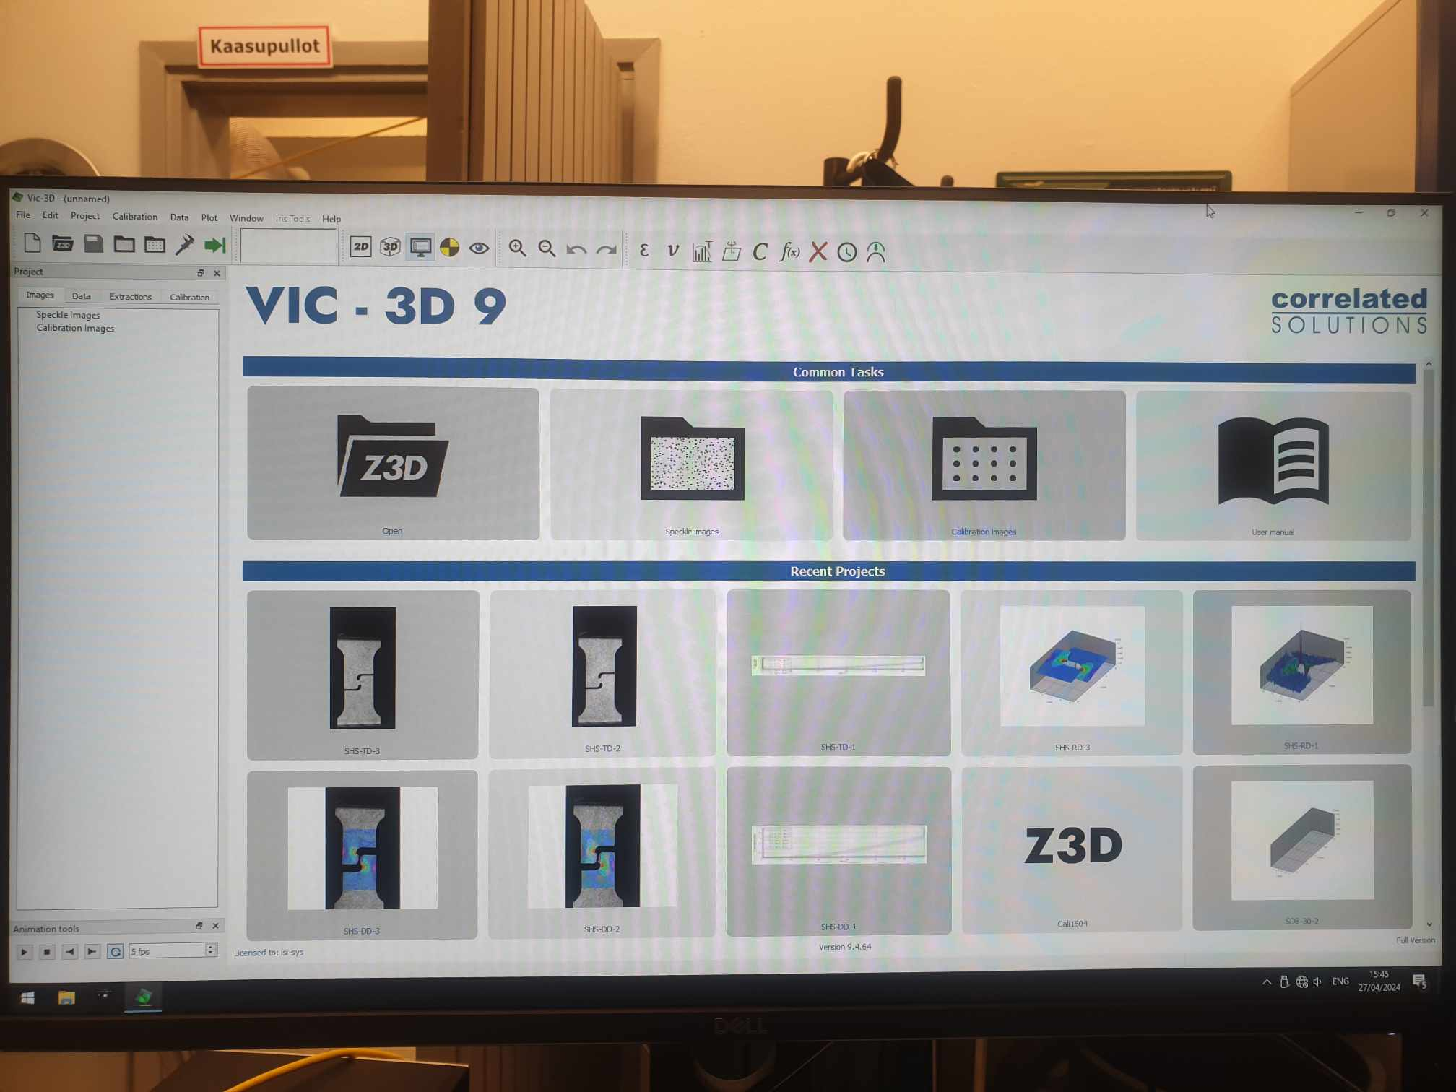

## 4.1 Calibration process

At the front page, we can safely ignore others and focus only on two options: Speckle image and Calibration image. Imagine that someone comes to the DIC system and changes the camera as their specimen have different scales, and after they leave, the cameras are not the same as before.

As a result, we should check that camera should look at the same point FOR OUR OWN CASE. If not, we should change the camera position. To ensure this, we place the calibration block at the focus point of the two cameras that are already calibrated and take a series of pictures (such as 30 pictures) by Vic Snap, and we save them later for Vic 3D calibration option.

Calibration is essential every time the camera setup is changed, as changes can impact the accuracy of the correlation analysis. Achieving a calibration score below 0.03 indicates satisfactory camera position, with a score of 0.017 serving as validation of the setup's accuracy [2].

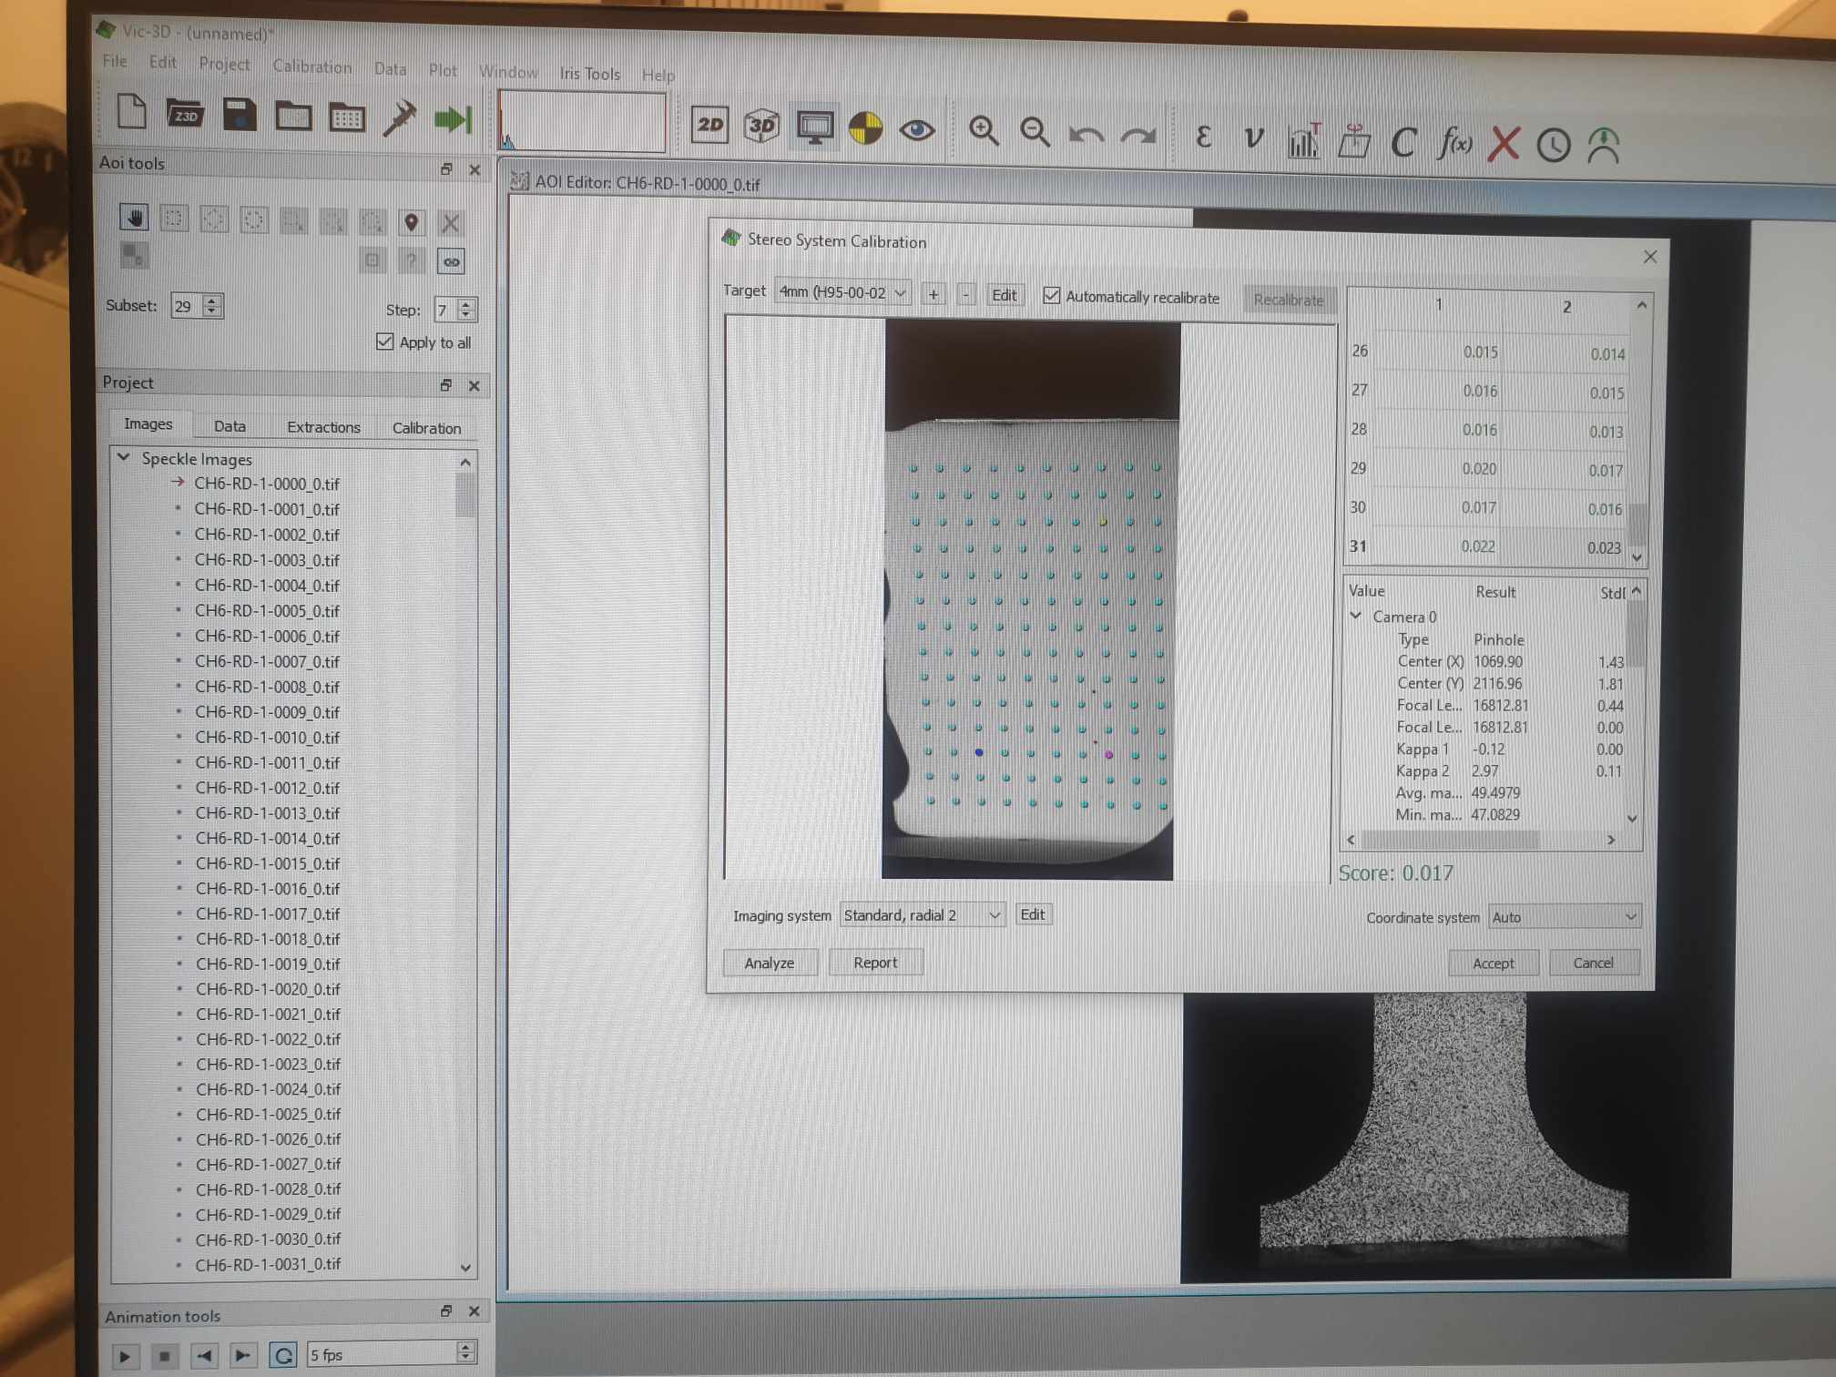

4.2 Defining the test area

In Vic 3D, the main test area on the specimen is defined by creating a rectangular selection around the gauge length. The first thing we need to define is the main test area of this specimen.

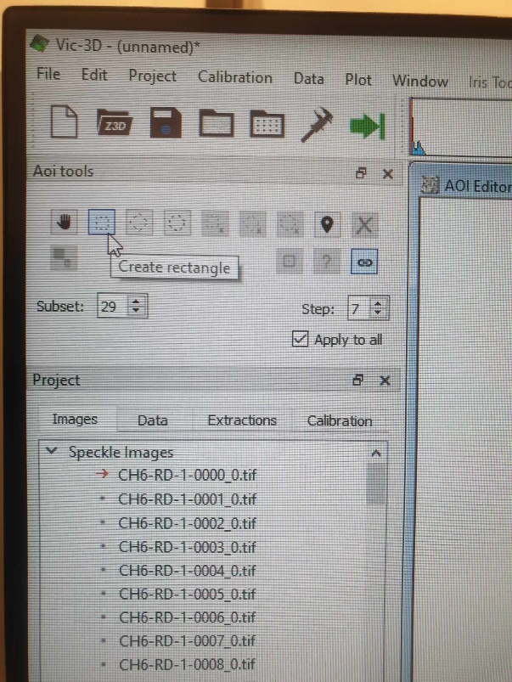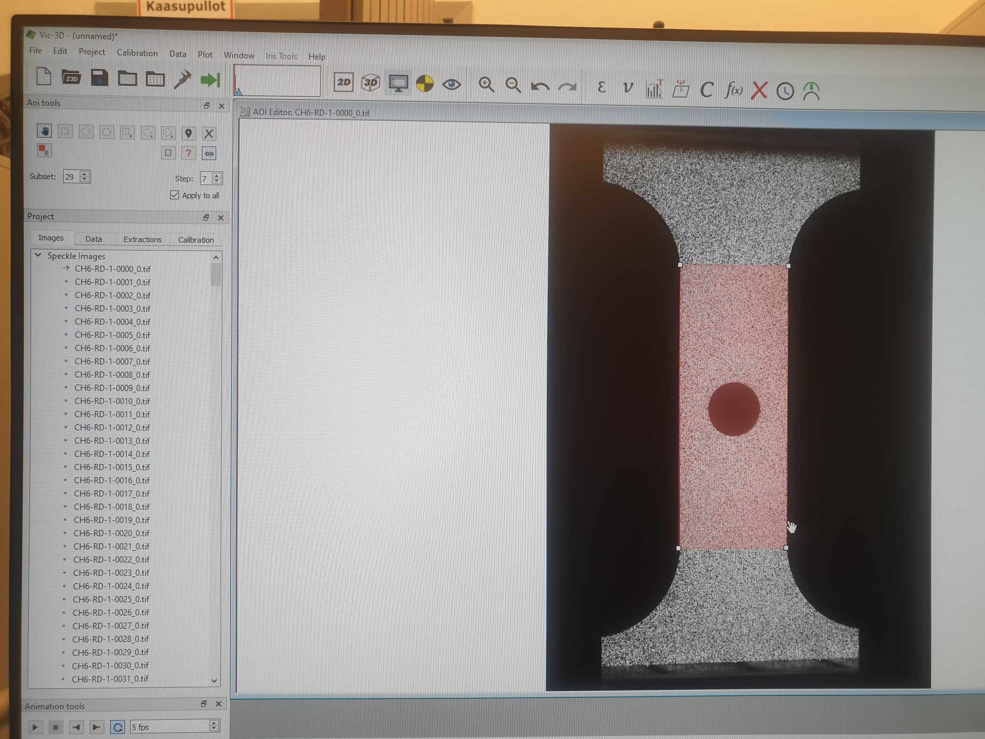

We click “Create rectangle” to create the rectangle on the specimen gauge that is perfectly touching om where the curves of the arc ends. By experience, when we define the rectangles, we should not let the red edges touch the edge of the specimen at all. This helps to avoid errors in calculations later such as in the contours plot. Therefore, we can move the red edge a little bit inside so that it does not touch the edge of the specimen.

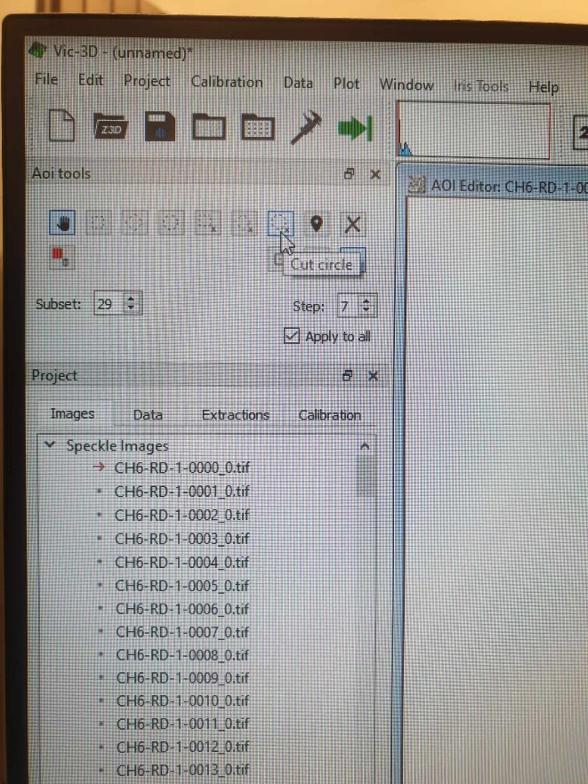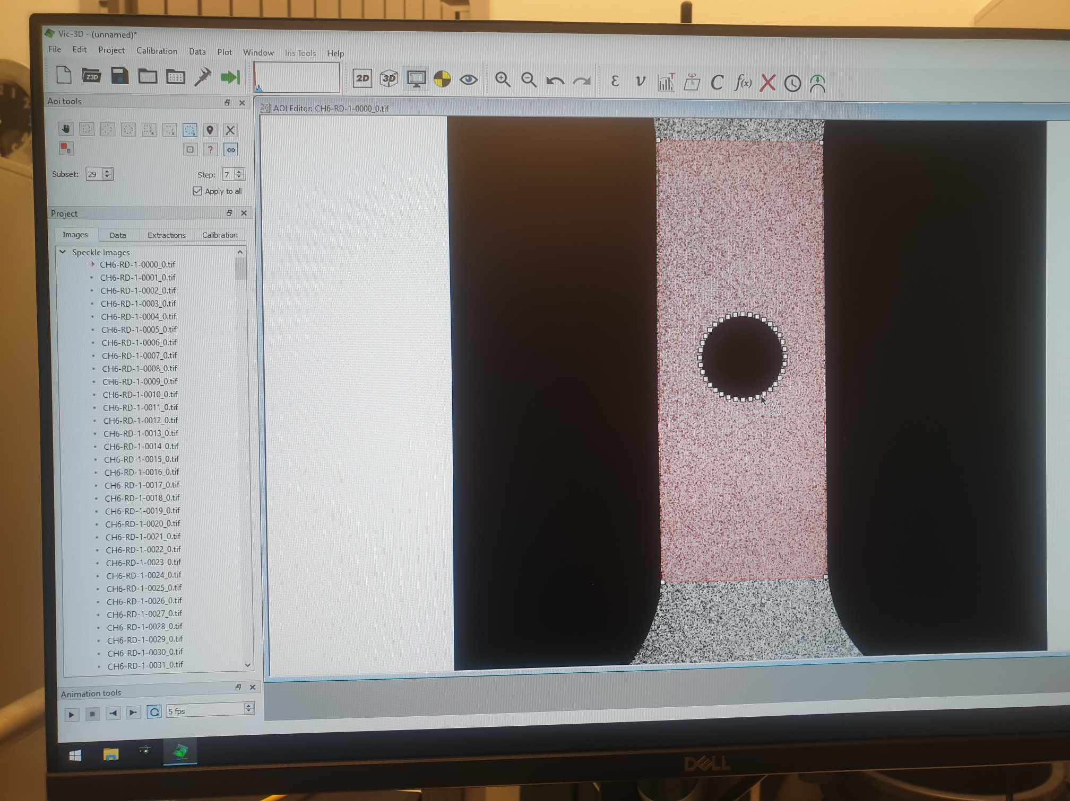

However, the specimens have some inside shapes that are empty. For example, central hole specimen has an empty hole, shear has some complex empty shape inside, and we cannot let the DIC system calculate correlation over these empty areas. As a result, we choose the option “Cut circle” and remove the circle at the center of Central Hole specimen. Now we see the central hole is no longer marked with red color of the rectangle box.

* For SDB, it is simple to process because there is no empty part inside at all.
* For NDB, it is simple as we only need to define an arc that matches the notched shape.
* For CH, it is not difficult as we can use the Cut circle demonstrated above.
* For Shear, it is very complex to define cut regions. Typically, it would require us to use many cut circles and arcs until the inside empty part of shear is totally removed.

## 4.3 Subset and filter settings

In defining the subset for analysis, Vic 3D provides suggestions which can be accessed via the help section; for instance, a subset value of 23 might be recommended. The filtering settings in the analysis should follow the rule of thumb:

2 * subset size <= filter size * step [2]

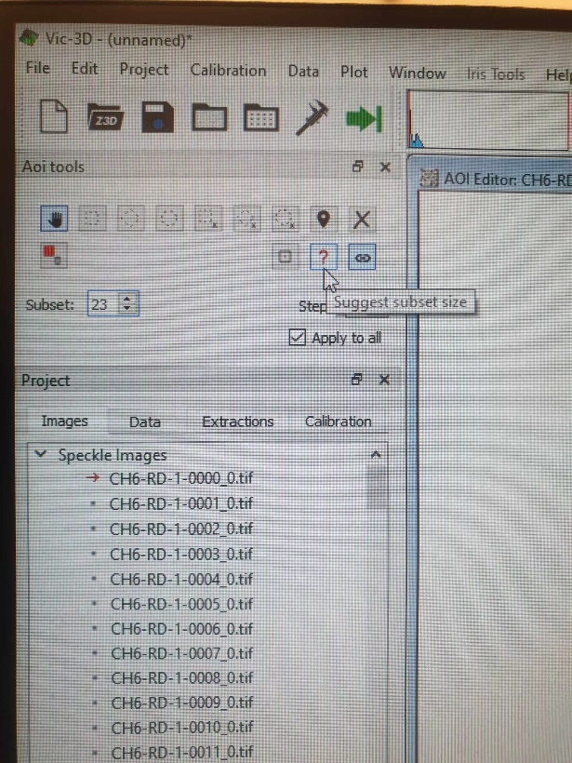 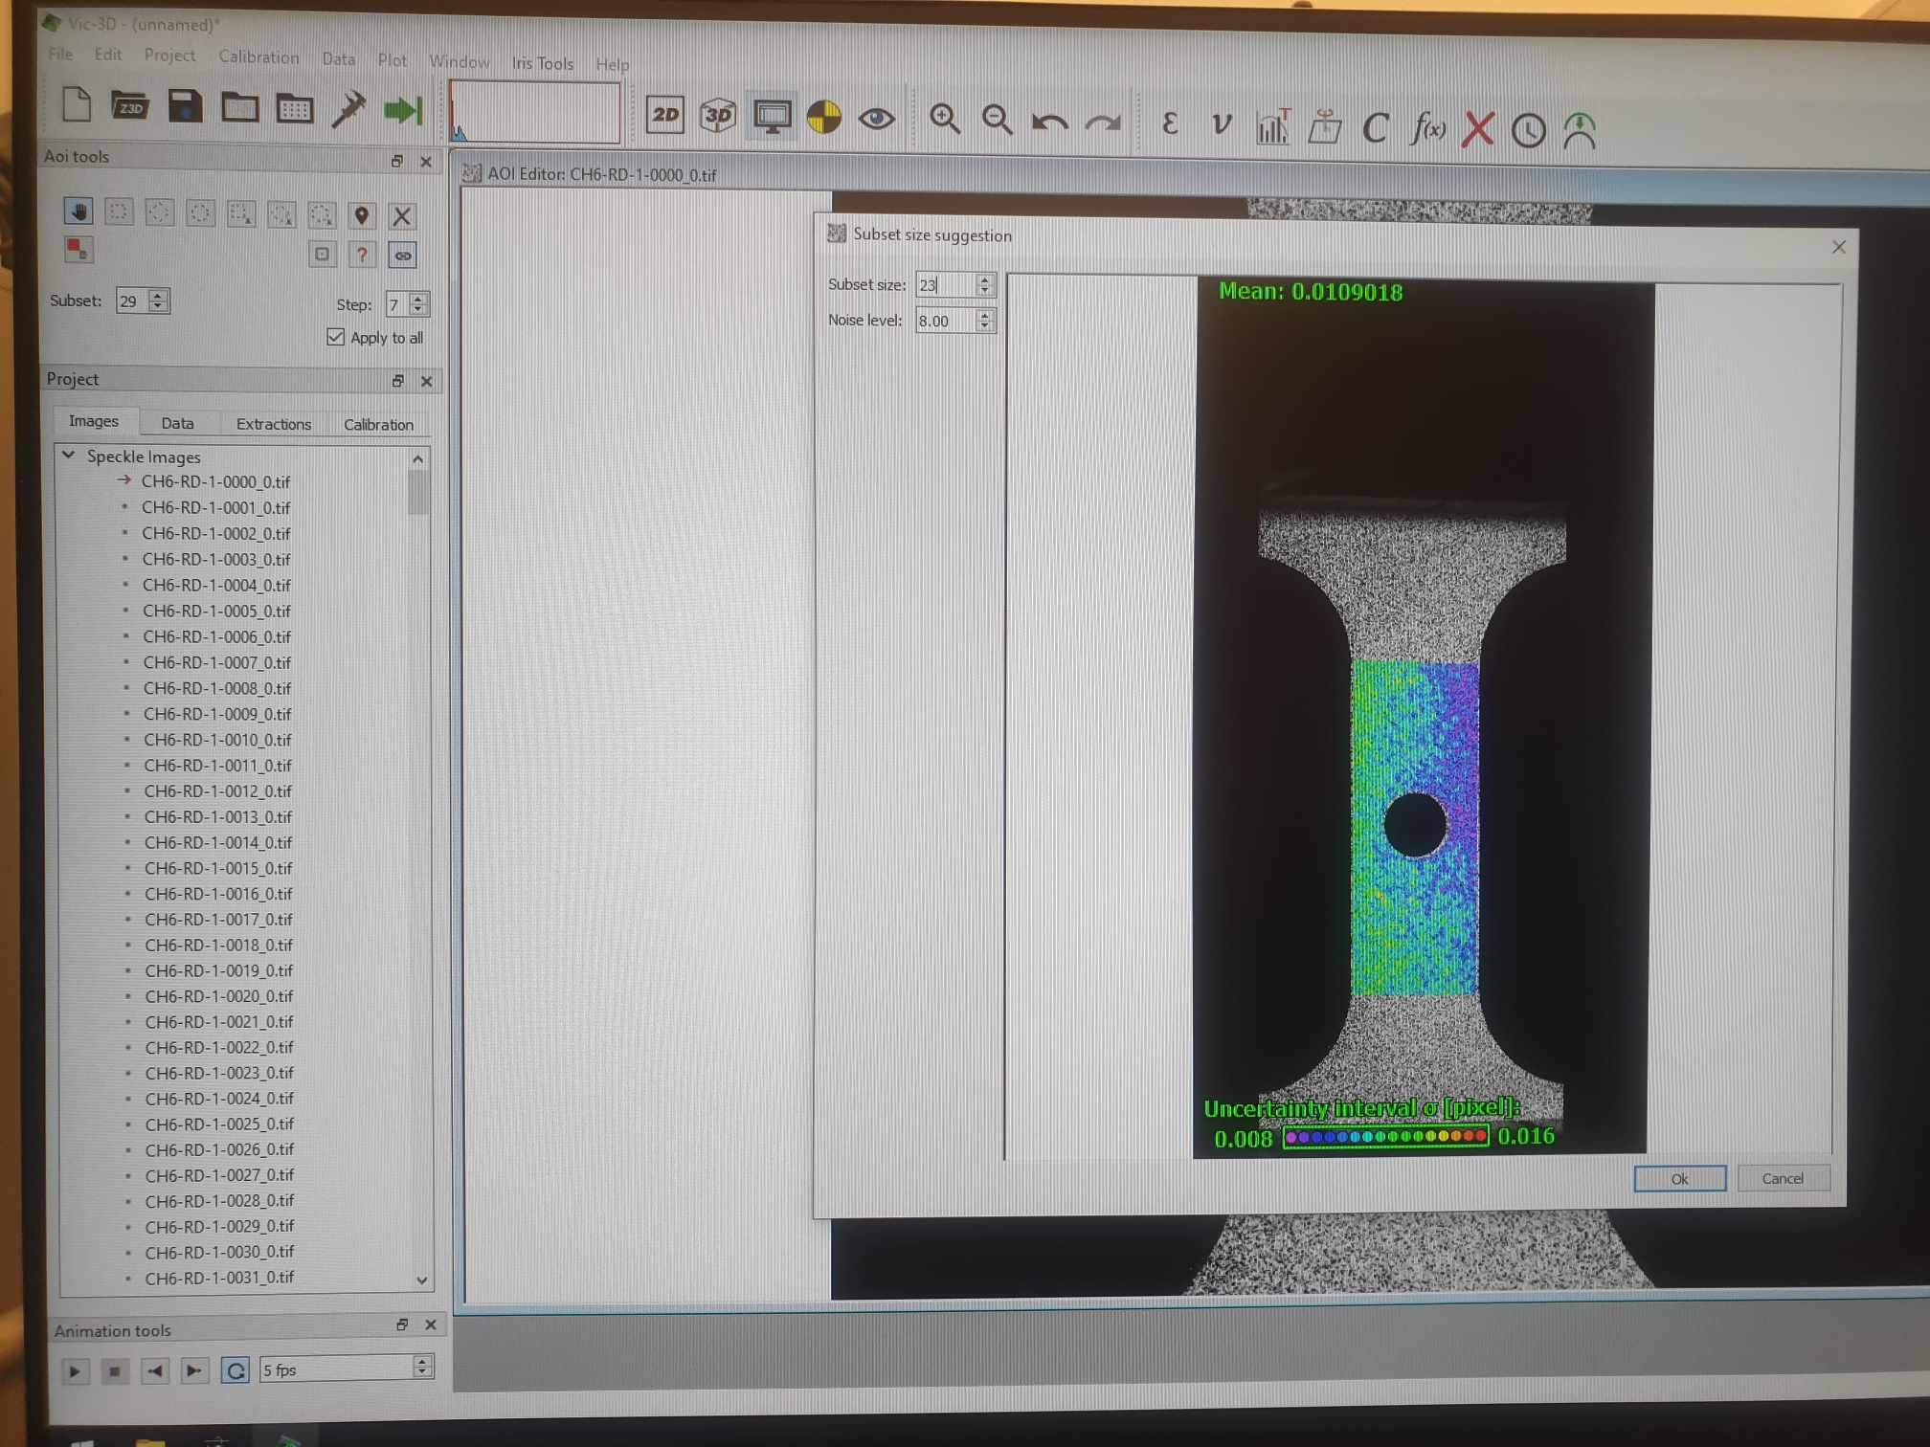

As we can see, the subset size is 23, step is 7, and filter size is 11 (defined later) The equation satisfies: 2×23≤11×7. Everything is ready, and we click on the green arrow to start analysis

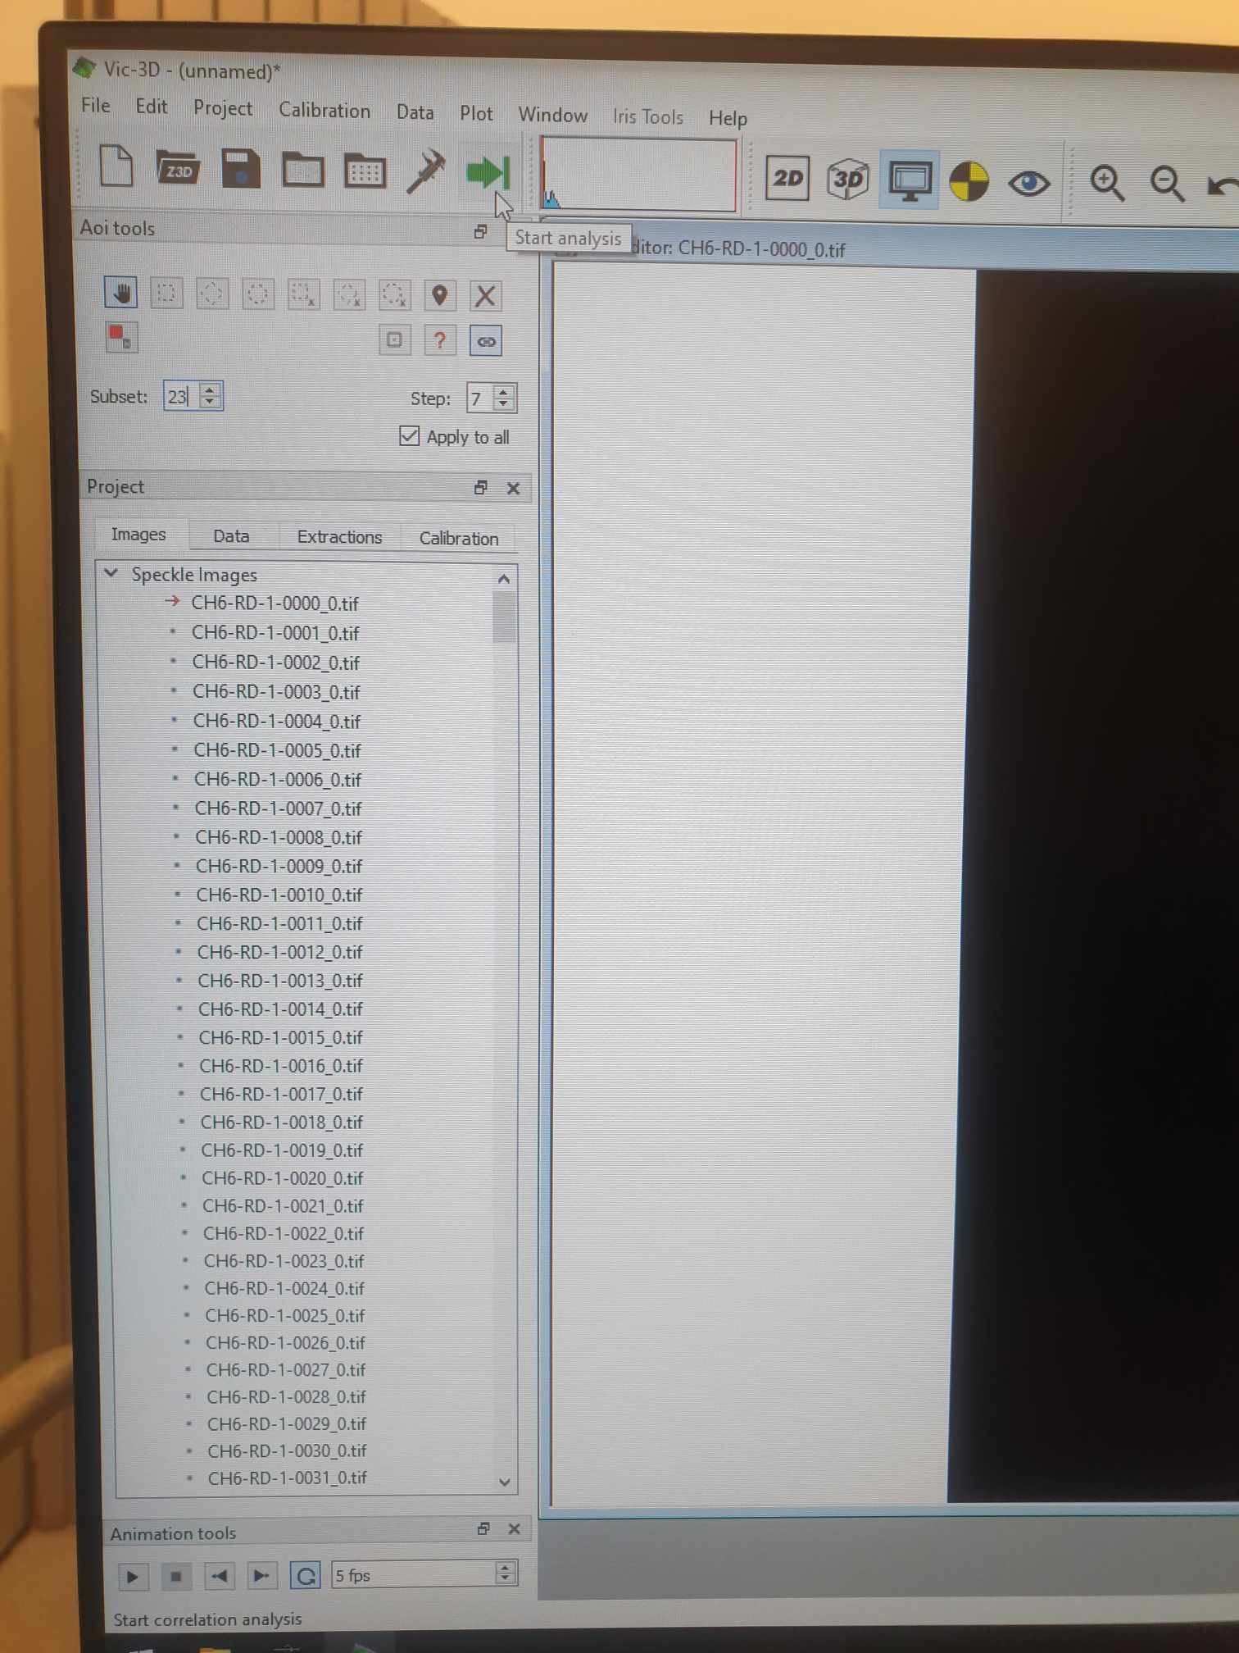

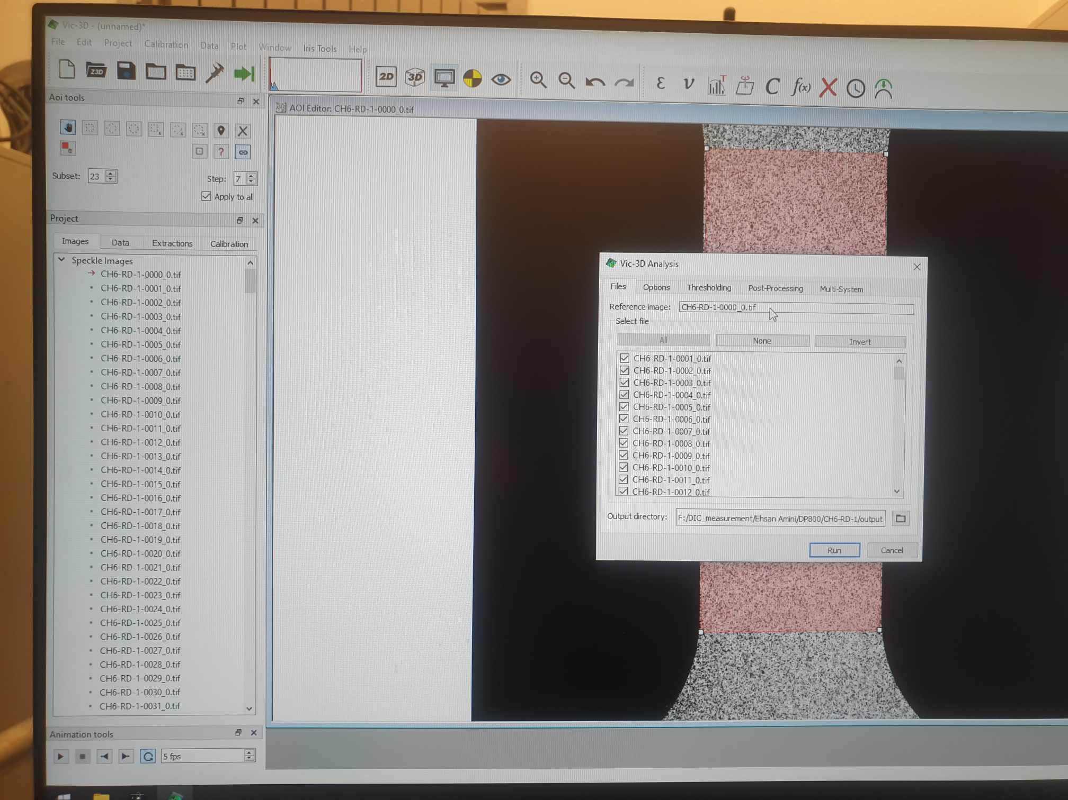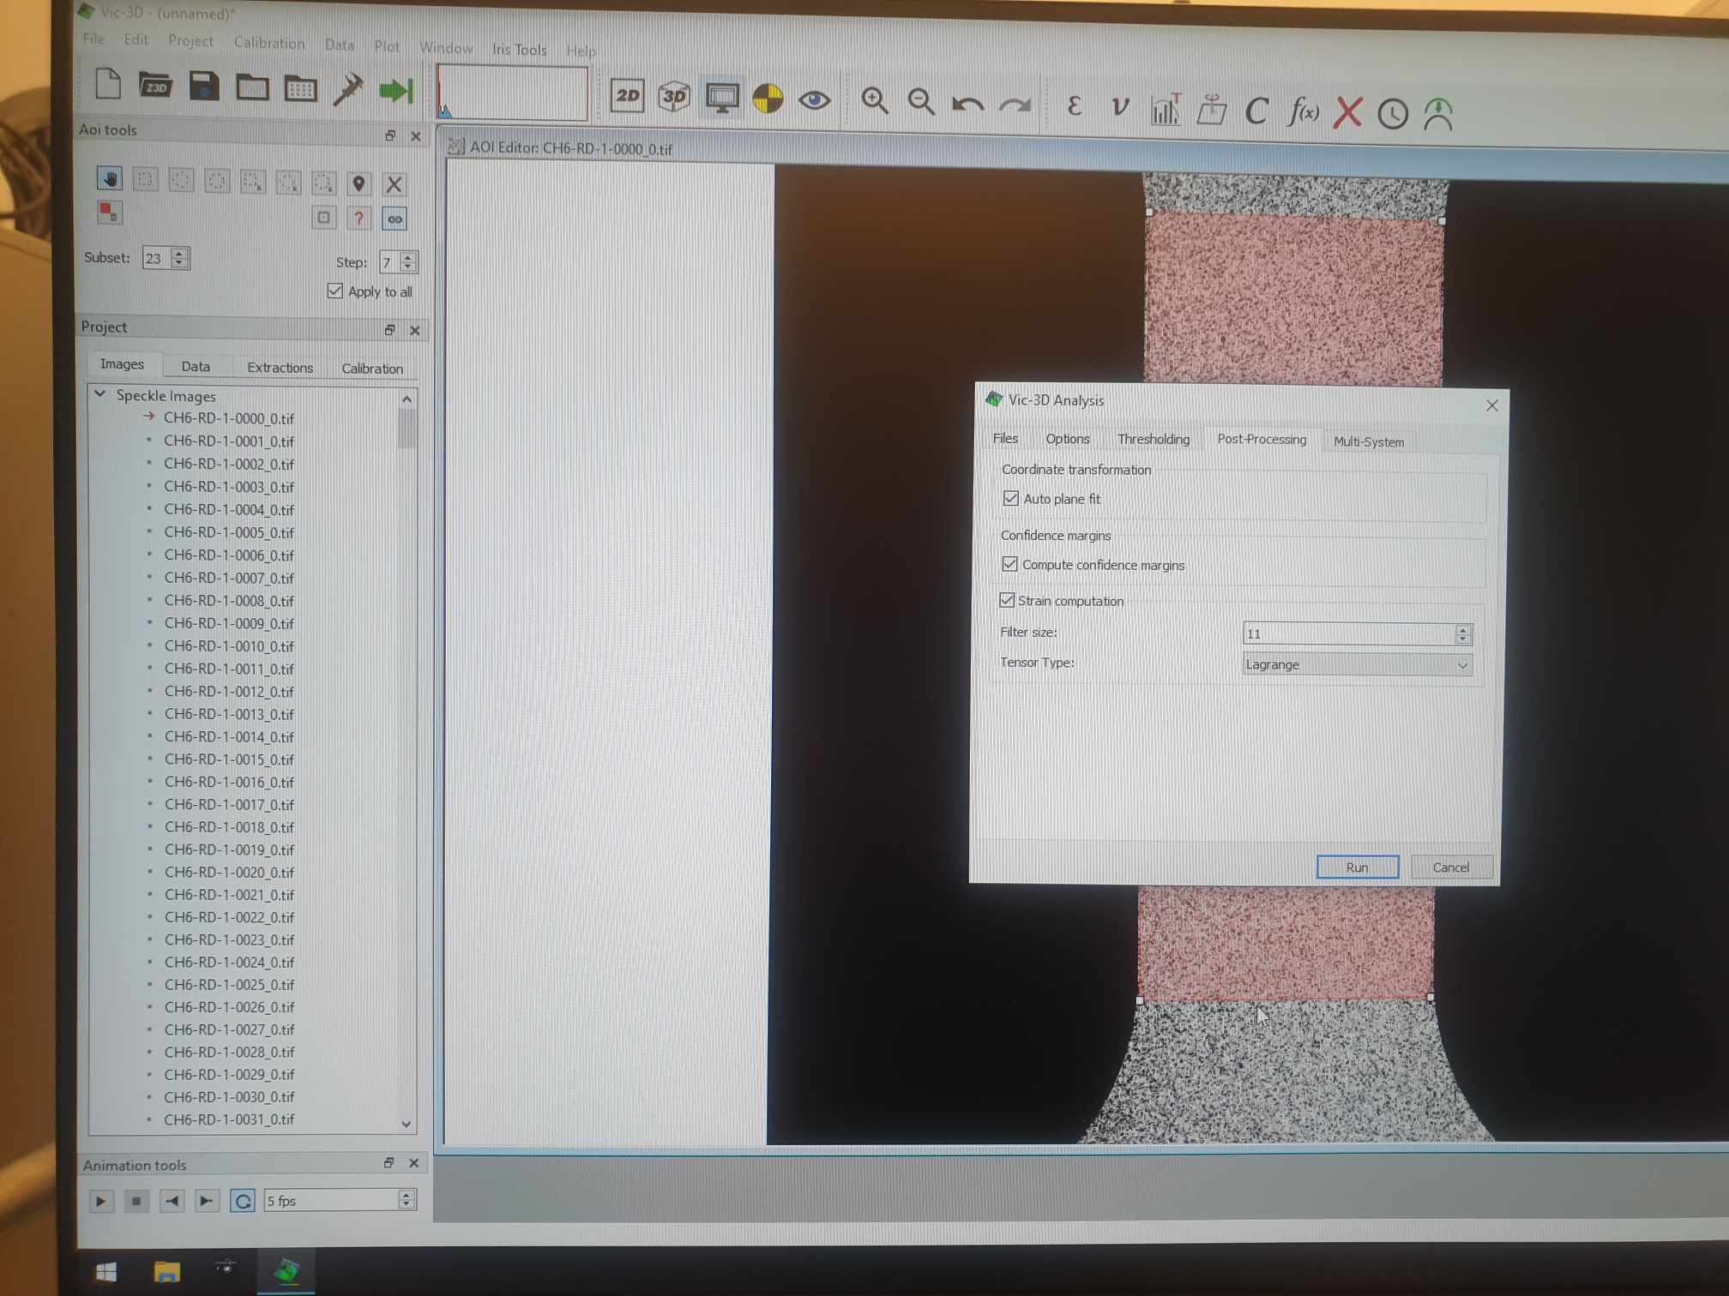

In Vic-3D analysis window, Postprocessing tab, we choose Filter size as 11. In the Files tab, the reference image is simply the first TIF image to start the correlation analysis

## 4.4 Running DIC analysis

During post-processing, it's possible to select various contour variables, such as 'eyy' for measuring Lagrange strain in the y-direction.

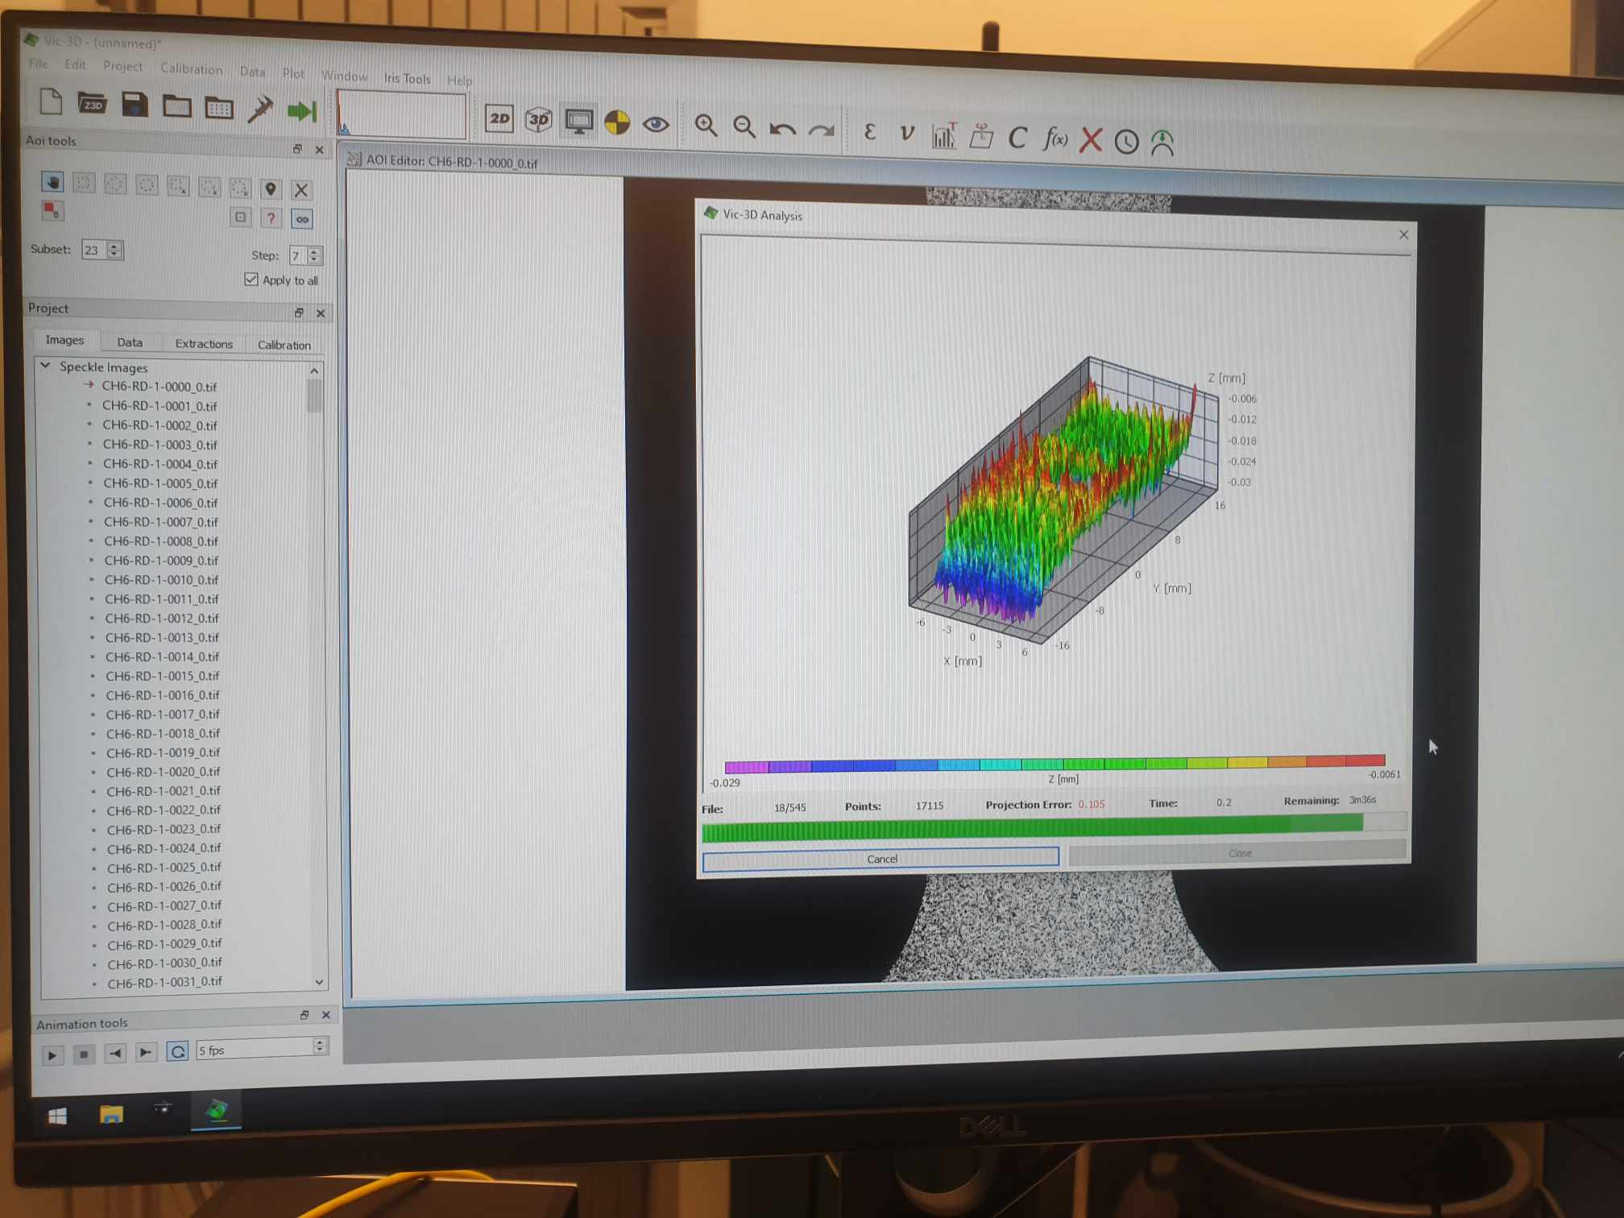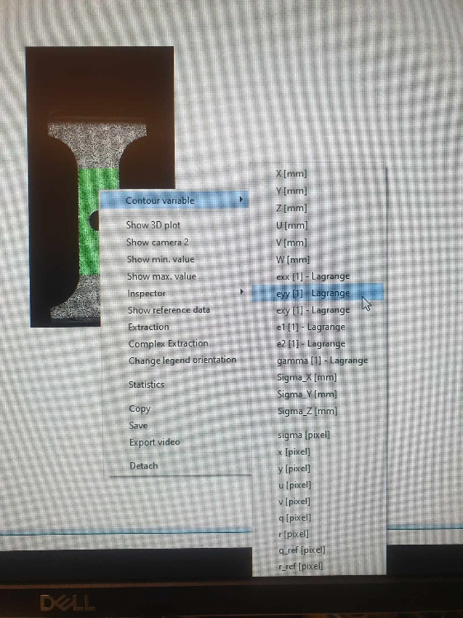

## 4.5 Applying extensometers

In Vic 3D, an extensometer functions as a virtual tool designed to measure specific regions of deformation along the specimen during testing. It allows for precise tracking of changes in length and displacement, providing critical data on material behavior under load.

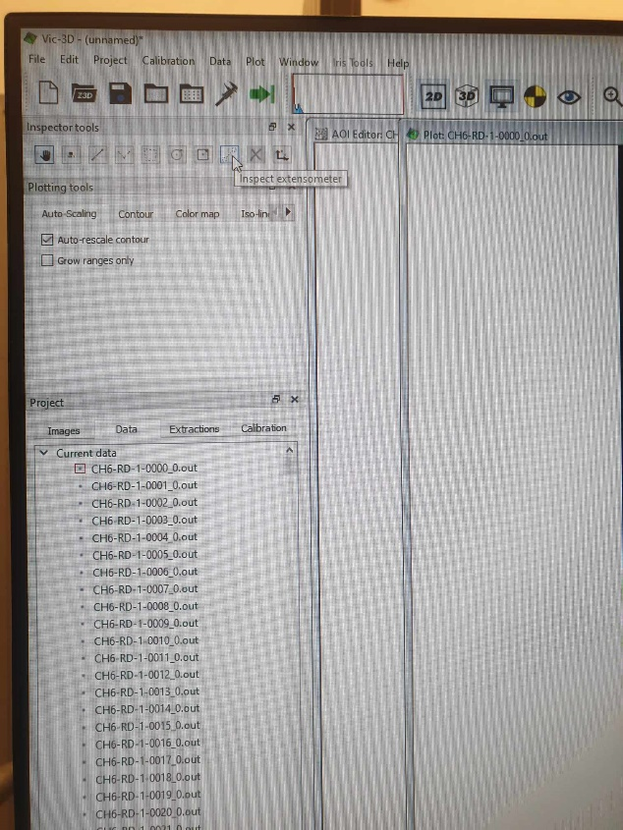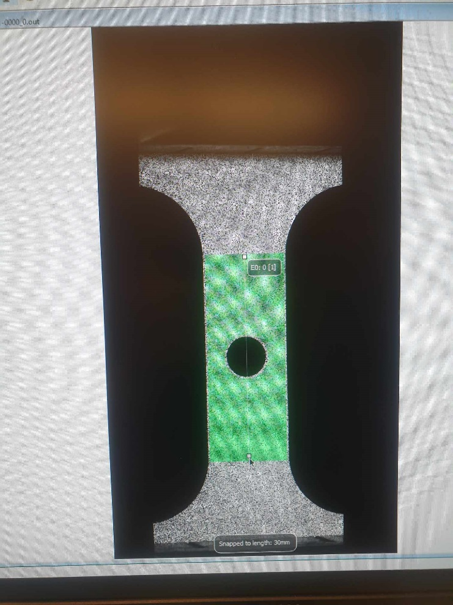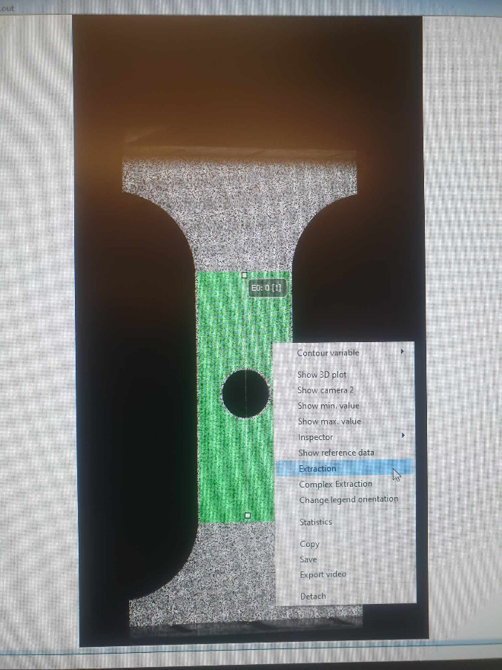

The initial setup of an extensometer should be along the length where significant displacement is expected, ideally in the center of the test section. This setup helps in measuring changes in length (delta L) accurately across the specimen. Then we choose the “Inspect extensometer” button. Then we can define the extensometer as 30 mm (length of the specimen) in the picture. However, manually doing this would not help us result in perfectly rounded 30 mm. To fix this, we press Ctrl, and we would achieve an integer number of millimeters.

After we have defined the extensometer, we can right click and choose Extraction option

## 4.6 Plotting options

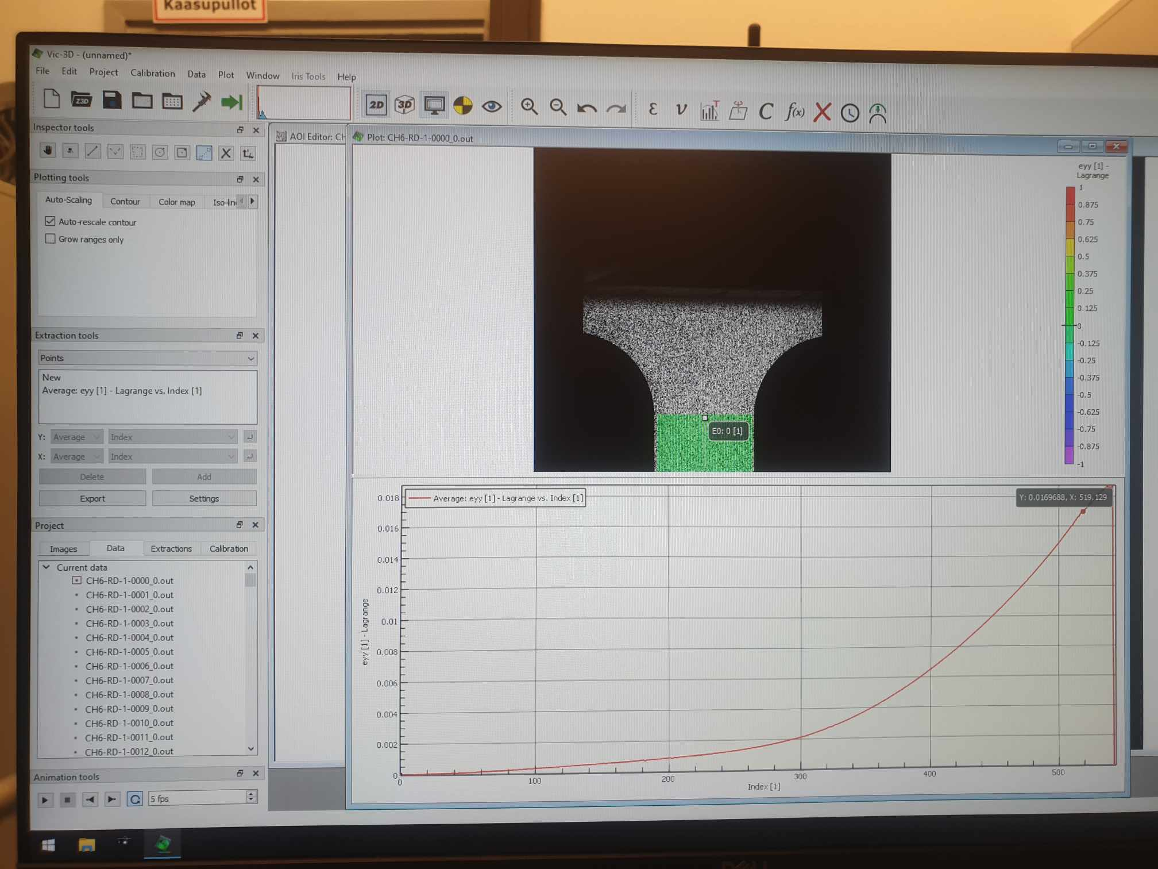

If we see any noticeable vibrations at the end of the test graph, it could indicate a separation (falling off) of the paint or speckle from the specimen surface, usually due to large displacements. This vibration in result image is usually unwanted but negligible enough to not affect results. In extraction tools box, first we need to choose extensometers option

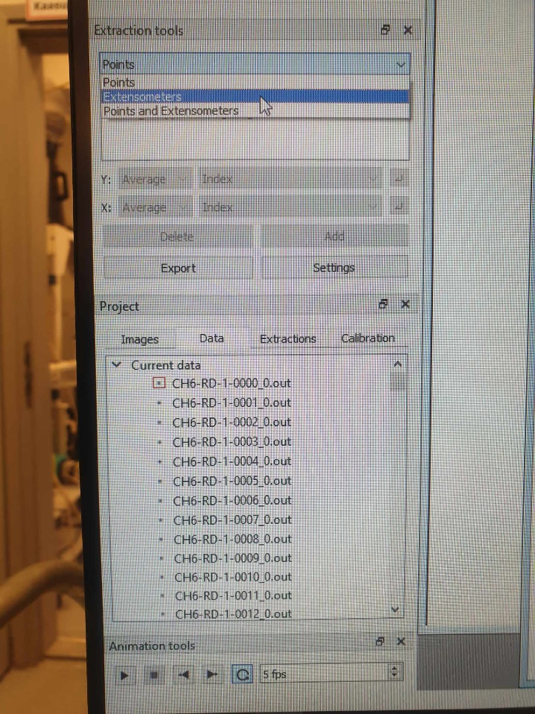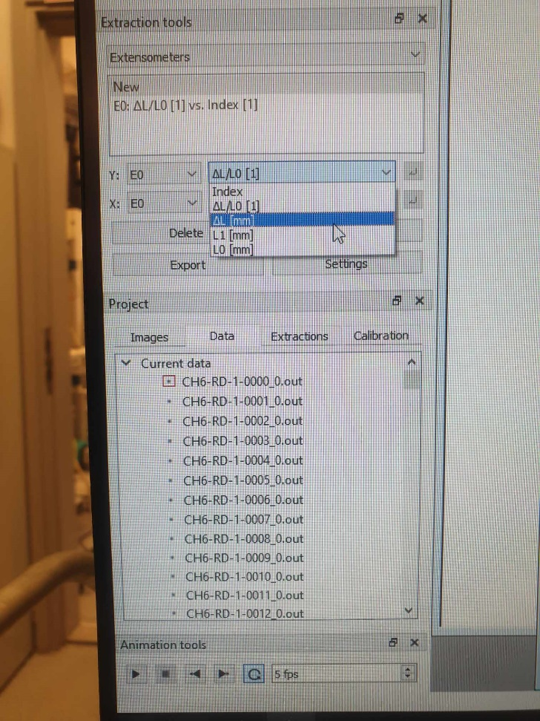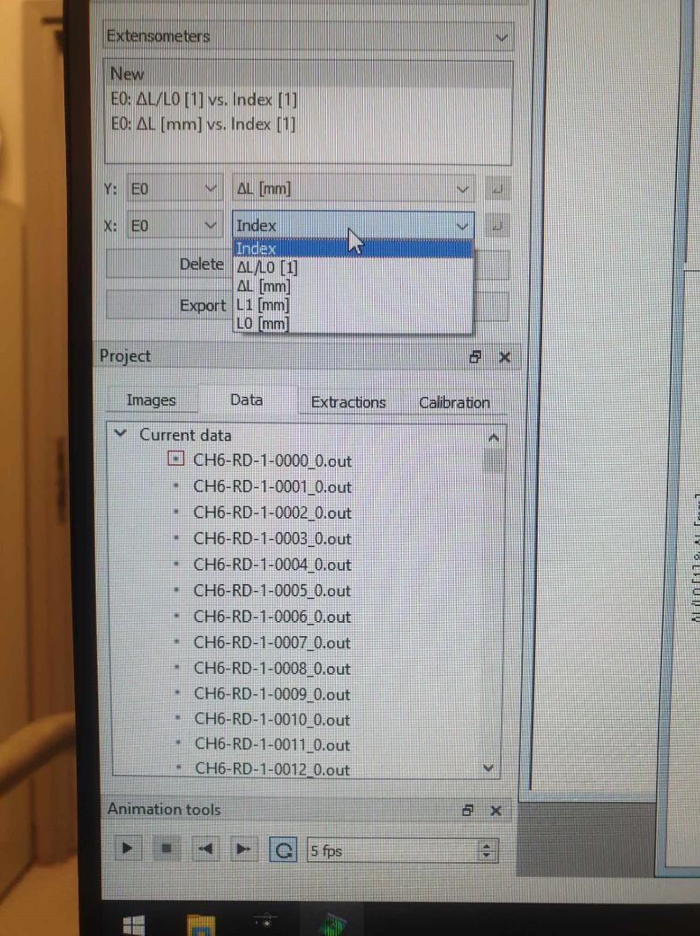

Then under Y box, we can choose delta L (mm), and under X box, we can choose the index of the images taken by Vic Snap. We can choose whatever options for Y and X box for further plotting. DIC results thus returns 5 specific values: Index of image, L0, L1, delta L and delta L/L0. Additionally, E0 is just the name of the extensometer. We would have E1, E2, etc if we define more extensometers in the previous stage.

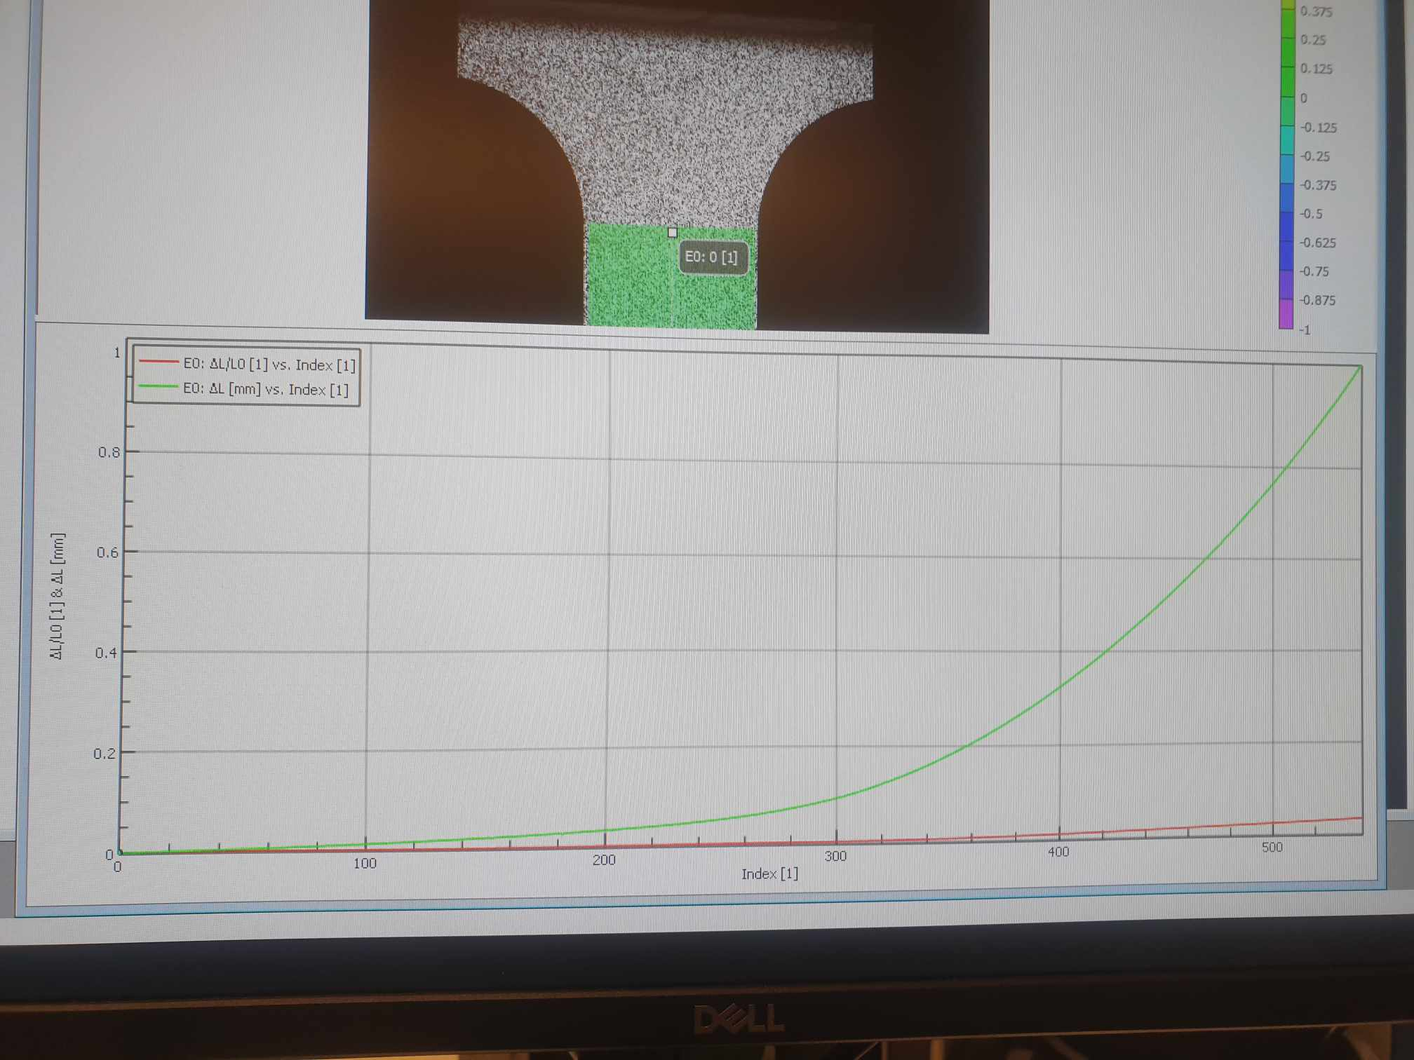

For example, we can plot two curves like the figures below. Of course, we can export the data and plot these curves again using Python/Matlab.

## 4.7 Data export

The results from the DIC analysis, including point-to-point graphs and other relevant metrics, can be exported to a CSV file for further analysis or reporting.

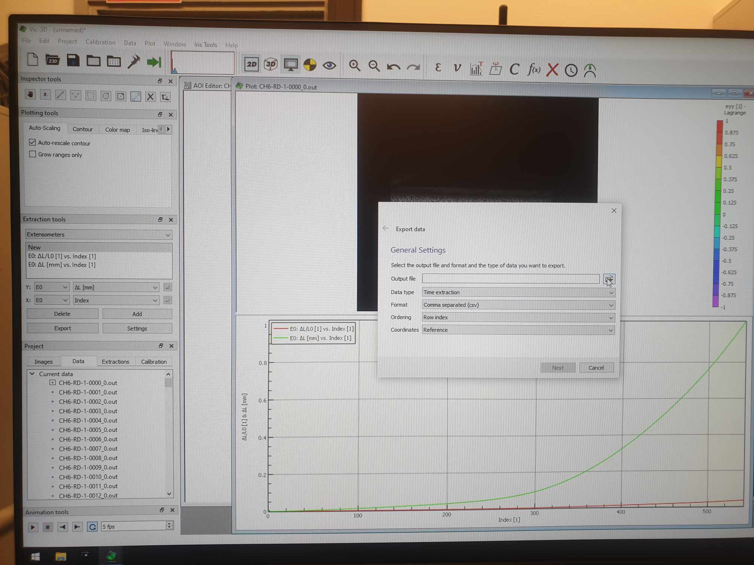

From here, we can click Next to export the csv file. Additionally, video of the analysis can be exported, but we first remove the extensometer line so that it does not appear in the exported video.

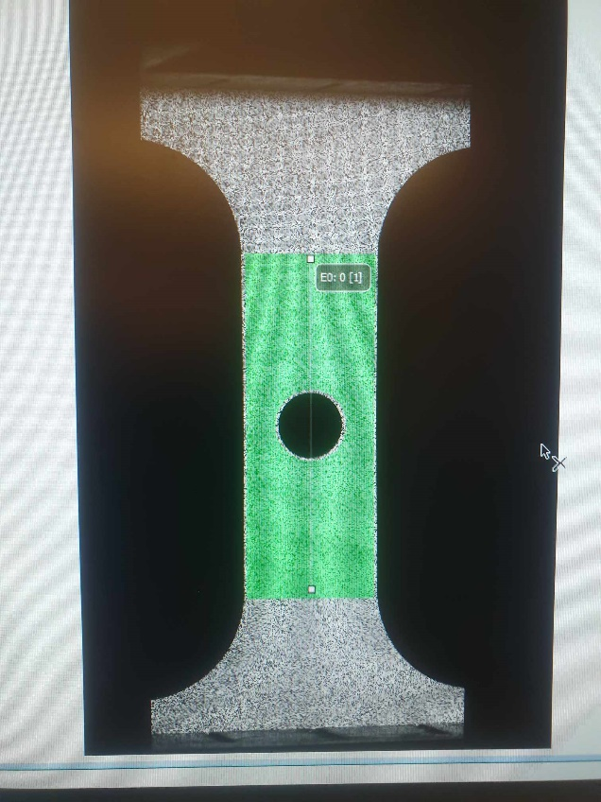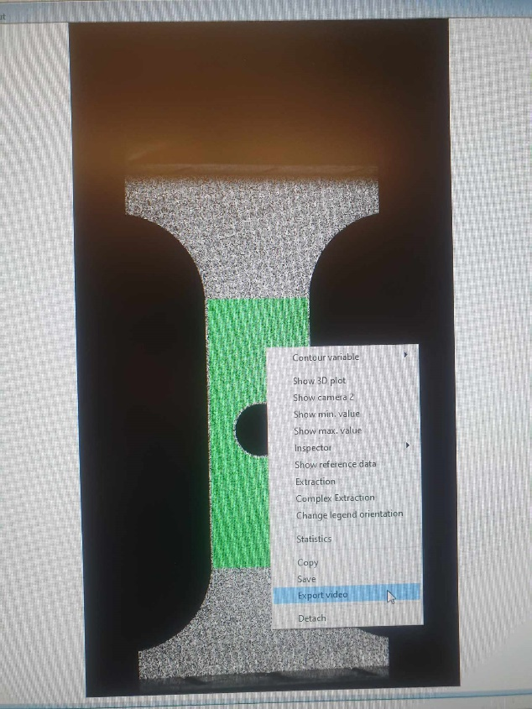

# Results

After exporting the data, we can calculate many properties such as engineering stress strain curve, true stress strain curve and R-value (not in this case since we don’t have thickness related data). The exported data belongs to NDBR25, since data of central hole and shear geometries are still private data at the time of DIC testing. There are a lot of outputs, and there is documentation here

<https://correlated.kayako.com/article/28-output-variables-in-vic-2d-and-vic-3d>

**Always Present**

X [mm] – metric position along the X-axis (by default, the horizontal axis).

Y [mm] – metric position along the Y-axis (by default, the vertical axis).

Z [mm] – metric position along the Z-axis (by default, the out-of-plane axis).

U [mm] – metric displacement along the X-axis, from the reference image. For the reference image, this value will always be 0.

V [mm] – metric displacement along the Y-axis.

W [mm] – metric displacement along the Z-axis.

ΔL/L0 - the change in length (ΔL) divided by the original length (L0) of the specimen. It is a dimensionless value indicating how much the specimen has elongated relative to its initial length.

ΔL [mm] - the absolute change in length of the specimen, measured in millimeters.

L1 [mm] - final length of the specimen after deformation, measured in millimeters. It is the sum of the original length plus any changes due to applied stress.

L0 [mm] - original length of the specimen before any load was applied, measured in millimeters.

**Strain variables**

exx [1] – strain in the X-direction. Positive numbers indicate tension; negative numbers indicate compression.

eyy [1] – strain in the Y-direction.

exy [1] – shear strain.

e1 [1] – the major principal strain.

e2 [1] – the minor principal strain.

gamma [1] – the principal strain angle, measure counterclockwise from the positive X-axis.

**Confidence Margins**

Sigma_X [mm] – the 1-standard-deviation (67%) uncertainty in the X-axis.

Sigma_Y [mm] – the 1-standard-deviation (67%) uncertainty in the Y-axis.

Sigma_Z [mm] – the 1-standard-deviation (67%) uncertainty in the Z-axis.

However, DIC results are simply visual results, so we can only have displacement and strain data. We need to combine the stress and force values from the tensile test (recorded by TestXpert) to derive meaningful data, such as force-displacement curve, engineering and true stress strain curves.

# Discussion and conclusions

The DIC testing for DP800 material was conducted meticulously, following standard procedures for specimen preparation, equipment calibration, and data acquisition. The detailed speckle pattern, careful calibration, and synchronized data collection enabled the accurate depiction of the material’s deformation under stress, obtaining reliable insights into its mechanical properties. This method ensures repeatability and reliability in our material testing processes.

# References

[1] International Digital Image Correlation Society, Jones, E.M.C. and Iadicola, M.A. (Eds.)

(2018). A Good Practices Guide for Digital Image Correlation. DOI: 10.32720/idics/gpg.ed1

[2] Guide for uniaxial tension test at room temperature with DIC measurement (DIC manual at the DIC testing lab)